DIU SECURE STUDENT BANK SYSTEM (DSSBS)

Submitted By

Student Name | Student ID
Muhammad Tanjeem | 252-15-817
MD. Sabbir Hossain Shamim | 252-15-825
Tamim Jobayer | 252-15-516
Ayasur Rahman Siddique Jidan | 252-15-771
Robiul Islam Ratin | 252-15-604

M I N I L A B P R O J E C T R E P O R T

This Report Presented in Partial Fulfillment of the course C S E 1 2 4 :
D a t a S t r u c t u r e L a b in the Computer Science and
Engineering Department


D A F F O D I L I N T E R N A T I O N A L U N I V E R S I T Y
Dhaka, Bangladesh

April 19, 2026

D E C L A R A T I O N
We hereby declare that this lab project has been done by us under the supervision of MD . J a k a r i a Z o b a i r , Lecturer , Department of Computer Science and Engineering, Daffodil International University. We also declare that neither this project nor any part of this project has been submitted elsewhere as lab projects.

Submitted To:

MD. Jakaria Zobair
Lecturer
Department of Computer Science and Engineering
Daffodil International University

Submitted by

Tanjeem

Muhammad Tanjeem
ID: 252-15-178
Dept. of CSE, DIU
Sabbir  MD. Sabbir Hossain Shamim 252-15-825  Dept. of CSE , DIU | Tamim  Tamim Jobayer  252-15-516  Dept. of CSE, DIU
Jidan  Ayasur Rahman Siddique Jidan  252-15-771  Dept. of CSE, DIU | Ratin  Robiul Islam Ratin  252-15-604  Dept. of CSE, DIU

C O U R S E & P R O G R A M O U T C O M E

The following course have course outcomes as following:.

Table 1: Course Outcome Statements
CO’ s | Statements
CO1 | Design the concept of fundamentals of data structure for solving real-life problem having  complex engineering attributes.
CO2 | Solve a real-life problem having application of abstract data type created within the scope of  complex engineering problem solving with the apply modern tools.
CO3 | Apply Data Structure to solve real world problems member in diverse team.

Table 2: Mapping of CO, PO, Blooms, KP and C E P

CO | PO | Blooms | K P | C E P
CO1 | PO3 | C6 | KP 5 | EP 1,EP 3
CO2 | PO5 | C3 | KP 6 | EP 1,EP 2
CO3 | PO9 | C3, A3 | KP 3 | EP 1

The mapping justification of this table is provided in section 4.3.1, 4.3.2 and 4.3.3.

Table of Contents

Declaration | i
Course & Program Outcome | ii
1 Introduction | 1
1.1 Introduction . . . . . . . . . . . . . . . . . . . . . . . . . . . . . . . . . . . . . . . | 1
1.2 Motivation . . . . . . . . . . . . . . . . . . . . . . . . . . . . . . . . . . . . . . . | 1
1.3 Objectives . . . . . . . . . . . . . . . . . . . . . . . . . . . . . . . . . . . . . . . . | 2
1.4 Feasibility Study . . . . . . . . . . . . . . . . . . . . . . . . . . . . . . . . . . . . | 3
1.5 Gap Analysis . . . . . . . . . . . . . . . . . . . . . . . . . . . . . . . . . . . . . . | 3
1.6 Project Outcome . . . . . . . . . . . . . . . . . . . . . . . . . . . . . . . . . . . . | 3
2 Proposed Methodology/Architecture | 4
2.1 Requirement Analysis & Design Specification . . . . . . . . . . . . . . . . . . . . | 4
2.1.1 Overview . . . . . . . . . . . . . . . . . . . . . . . . . . . . . . . . . . . . | 4
2.1.2 Proposed Methodology/ System Design . . . . . . . . . . . . . . . . . . . | 5
2.1.3 UI Design . . . . . . . . . . . . . . . . . . . . . . . . . . . . . . . . . . . . | 6
2.2 Overall Project Plan . . . . . . . . . . . . . . . . . . . . . . . . . . . . . . . . . . | 6
3 Implementation and Results | 9
3.1 Implementation . . . . . . . . . . . . . . . . . . . . . . . . . . . . . . . . . . . . . | 9
3.2 Performance Analysis . . . . . . . . . . . . . . . . . . . . . . . . . . . . . . . . . . | 30
3.3 Results and Discussion . . . . . . . . . . . . . . . . . . . . . . . . . . . . . . . . . | 31
4 Engineering Standards and Mapping | 47
4.1 Impact on Society, Environment and Sustainability . . . . . . . . . . . . . . . . . | 47
4.1.1 Impact on Life . . . . . . . . . . . . . . . . . . . . . . . . . . . . . . . . . | 47
4.1.2 Impact on Society & Environment . . . . . . . . . . . . . . . . . . . . . . | 47
4.1.3 Ethical Aspects . . . . . . . . . . . . . . . . . . . . . . . . . . . . . . . . . | 47
4.1.4 Sustainability Plan . . . . . . . . . . . . . . . . . . . . . . . . . . . . . . . | 48
4.2 Project Management and Team Work . . . . . . . . . . . . . . . . . . . . . . . . | 48
4.3 Complex Engineering Problem . . . . . . . . . . . . . . . . . . . . . . . . . . . . | 48
- Mapping of Program Outcome . . . . . . . . . . . . . . . . . . . . . . .  - Complex Problem Solving . . . . . . . . . . . . . . . . . . . . . . . . . .  - Engineering Activities . . . . . . . . . . . . . . . . . . . . . . . . . . . . . . | 48  49  50

Table of Contents Table of Contents
5 Conclusion 52
- Summary . . . . . . . . . . . . . . . . . . . . . . . . . . . . . . . . . . . . . . . . 52
- Limitation . . . . . . . . . . . . . . . . . . . . . . . . . . . . . . . . . . . . . . . . 53
- Future Work 53
References 55

Chapter 1

Introduction
This chapter presents the overall motivation and objectives of the proposed Student Bank Management System. It discusses the real-life problems faced by students in university financial activities and explains why this system has been developed. Additionally, it outlines the expected outcomes and benefits of implementing this system in a practical environment.

- Introduction


Our system was developed specifically for the students of our university to address the common hassles they face during fee payments. Traditionally, students had to spend significant time physically visiting campus or banks, resulting in delays and inefficiency. Our platform, however, is fully integrated with the university accounts system, meaning that when students make payments through our system, the funds are directly transferred to their university account. As soon as the payment is processed, students immediately receive clearance and other confirmations. This seamless integration not only reduces delays but also ensures a secure and efficient financial process, improving both the academic.
Figure 1.1Agrani Bank Head Office Building, Bangladesh

- Motivation

The main motivation for this project came from the real financial and administrative problems students face during registration, clearance, transport fee payment, hall fee submission, and other university activities.
After final exam results are published, the university usually gives only 5 to 7 days for semester registration.
During this short period, many students who live in villages or outside Dhaka often go back home for semester break.
Without an online account-based payment system, they must stay near campus or return physically just to submit fees, which causes loss of vacation time and extra cost.
Another major problem occurs in section selection and payment clearance.
Sometimes students pay through another bank or mobile financial service, but the confirmation gets delayed.
As a result, they cannot immediately prove payment to their advisor, which may stop them from getting clearance on time and selecting their preferred section.
Our system solves this by providing instant payment confirmation and automatic clearance updates directly in the online portal.
The project is also highly useful for transport fee and hall fee payments.
Currently, students often need to pay fees at the Accounts Office, collect the receipt, and then physically show it to the Transport Office or Hall Management Office for approval.
This process wastes time and creates unnecessary hassle.
In our system, both the Transport Office and Hall Management modules will be integrated with the student banking platform.
Whenever a student pays the transport or hall fee through their account, the payment record will automatically appear in the related office portal.
Students will only need to show their online payment status or transaction ID, and the office can verify it instantly.
The system will also support core banking features such as student account creation, deposit, transfer, withdrawal request, and loan request within a fixed approved limit.
The Accounts and Finance Office will verify eligibility before approving loans or special requests.

- Objectives

The main objective of this project is to develop a Student Bank Management System that solves real university financial problems such as registration fee submission, transport fee payment, and hall fee clearance.
It aims to reduce physical crowd, save students’ time, and allow them to complete payments from anywhere through online account-based transactions.
Another objective is to provide instant payment verification and automatic updates to the related university offices for faster clearance.
The project also focuses on offering basic banking features like account creation, deposit, transfer, withdrawal, and loan request within a controlled limit.
Finally, it applies data structure concepts in a practical real-life university management system.

- Feasibility Study

Agrani Bank Limited uses a modern banking system that includes real-time online banking, account management, ATM services, digital banking, loan management, remittance system, and agent banking. These features ensure efficient and secure banking operations. The system also supports utility payments and government transactions, making it highly effective in real-life banking environments.

- G a p Analysis

After analyzing the system of Agrani Bank Limited, several gaps have been identified in our project. The system supports account creation, transaction handling, and loan management using data structures like linked list, queue, and stack. However, it lacks advanced features found in real banking systems. The system provides limited update functionality and only supports search by account number. It uses file-based storage instead of a database system and has only basic user roles. Although some security features like OTP and PIN are implemented, advanced security mechanisms are missing. Additionally, the system uses a console-based interface instead of modern web or mobile platforms. Therefore, the system is a simplified version and requires further improvements to match real-world banking systems.

- Project Outcome

The Bank Management System provides a simplified digital banking solution that helps users perform essential banking operations such as account creation, deposit, withdrawal, and fund transfer efficiently. The system enhances user understanding of secure transactions through OTP, PIN, and password-based authentication. It also includes loan management features, allowing users to request and repay loans. By using data structures like linked list, queue, and stack, the system ensures efficient data handling. This project is highly beneficial as a learning tool for students and can also be used in small-scale banking environments. Overall, it reflects the core functionalities of real banking systems in a simplified manner.
Chapter 2

Proposed Methodology/Architecture

This chapter presents the overall methodology and system architecture of the DIU Secure Student Bank System, describing how the system was planned, designed, and implemented over the development period. It highlights the workflow, core modules, data structures, and user interface design that ensure a secure, efficient, and user-friendly banking solution. The chapter also reflects how real-world requirements and structured development planning were integrated to achieve a complete and reliable system.

- Requirement Analysis & Design Specification

Overview
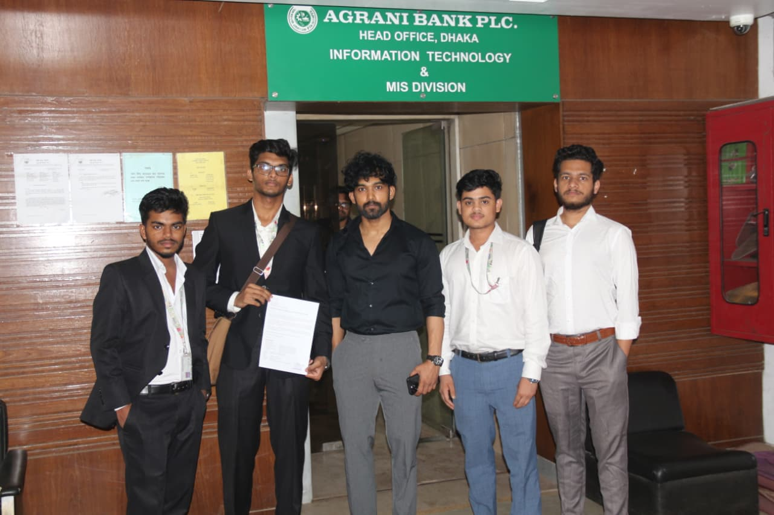
During our project work, we visited Agrani Bank Limited to gain practical knowledge about real-world banking systems and operations. Although detailed technical information about their internal software was not fully disclosed due to security and confidentiality reasons, we were able to observe and understand the overall banking workflow and services.
From our observation and discussion with bank officials, we learned that modern banking systems are highly
secure and centralized. All customer data, transactions, and account information are managed through a core banking system, which allows real-time operations across different branches.
Figure 2.1: Requirement analysis of Agrani Bank
The system performs essential functions such as account creation, deposit, withdrawal, fund transfer, and transaction recording. These operations are managed through secure authentication systems, including passwords, PINs, and internal verification processes. The system also maintains transaction history and supports loan management, where requests are processed and approved by authorized personnel.
We also observed that the banking system uses different types of user roles, such as
administrators and employees, to control access and ensure security. Each operation is carefully monitored and recorded to maintain accuracy and prevent fraud.
Although we could not directly access or analyze their software functions like insert, delete, or search, it is understood that such operations are handled internally through database management systems in a secure and controlled manner.
This visit helped us understand how real banking systems operate and allowed us to design our project as a simplified version of a real bank management system.

Proposed Methodology/ System Design

A structured representation of the overall system methodology and workflow is presented below.
Start
DIU SECURE STUDENT BANK SYSTEM
- Linked List (Account Management)
- Queue (Loan Requests)
- Stack (Transaction History)
- Insert, Delete, Search Operations
- File Handling System
- Authentication (Password, OTP, PIN)
- Security System (Account Lock)
- Banking Operations (Deposit, Withdraw, Transfer)
- Admin & Loan Management
- User Terminal
- Root Admin Terminal
- Account Management System
- Transaction System (Deposit, Withdraw, Transfer)
- Loan Management System
- Security System (Password, OTP, PIN, Account Lock)
- File System (bank.txt, transactions.txt)
Implementation using C Language
with functions and data structures
- Login Testing
- Transaction Test (Deposit, Withdraw, Transfer)
- Loan Testing
- Forget Password Testing
- Security Test (Password, OTP, PIN)
- Admin System Testing
- Data Auto Save & Load
- Account Lockout(Too many attempt Password, OTP, PIN)
- Bug Fixing
- Performance Check
- Time & Space complexity Check
Figure 2 Figure 2.2: Proposed Methodology of Secure Banking System

End
Figure 2.2: Proposed Methodology of Secure Banking System
The above figure illustrates the overall methodology of the system. It shows how different components such as data structures, banking operations, security system, user and admin modules, implementation, and testing are integrated to build the complete system. The diagram represents the step-by-step process starting from system initialization to final performance evaluation.

2.1.3 UI Design
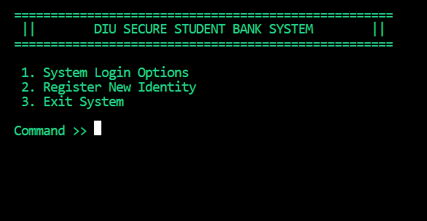
The user interface of the DIU Secure Student Bank System is a console-based, menu-driven interface designed to ensure simplicity, security, and ease of use. The system displays a structured main menu where users can select options such as login, registration, or exit using numeric commands.
A consistent header is shown on every screen, which helps maintain a clear and organized layout.
Figure 2.3: Initial Interface of DIU Secure Student Bank System

To enhance user experience, the interface uses color-based text where green indicates normal or successful operations, red shows errors or security alerts, and yellow is used for warnings such as OTP messages. The system provides clear instructions and real-time feedback for every action, making it easy for users to understand what is happening.

User inputs are validated at every step to prevent errors, and important operations require authentication through password, OTP, and PIN verification. In case of multiple failed attempts, the system automatically locks the account, ensuring strong security.

Although the interface does not include graphical elements, its clean structure, logical navigation, and interactive feedback make it user-friendly and effective for a banking system.

2.2 Overall Project Plan

The development of the DIU Secure Student Bank System was carried out over a continuous three-month period following a structured and implementation-driven methodology, where each stage of the system was designed, implemented, and validated based on real code-level functionality rather than only theoretical planning. The project demonstrates a gradual transformation from system design to a fully operational and secure banking simulation using the C programming language.

At the beginning of the project, the first two weeks were dedicated to system planning and architectural design. During this stage, the complete system workflow was conceptualized, including user interaction, admin control, transaction flow, and security layers. Based on efficiency and real-time performance considerations, specific data structures were selected directly aligned with the final implementation. A singly linked list was chosen for account management, as observed in the struct account design with dynamic memory allocation (malloc) and pointer-based traversal (search() function), enabling scalable account storage. Similarly, a queue structure using front and rear pointers was selected for loan request handling (enqueueLoan()), ensuring a fair FIFO-based approval system. A stack-based approach was implemented for transaction history (pushTransaction()), allowing LIFO access to recent financial activities. The successful definition of these structures and their logical necessity served as the foundational proof of this phase.

During weeks three and four, the focus shifted to implementing these core data structures into working modules. The linked list was fully developed with operations such as account creation, searching, and deletion, directly reflected in functions like createAccount() and search(). The queue mechanism for loan processing was implemented and tested through dynamic node insertion and removal, ensuring proper sequencing of requests. Additionally, the transaction stack was integrated with file parsing (showHistory()), demonstrating real-time reconstruction of transaction logs into memory. The successful execution of dynamic memory allocation, pointer manipulation, and correct data flow confirmed that the system's backbone was functioning efficiently.

In the next phase, spanning weeks five and six, the core banking functionalities were developed and integrated into the system. Functions such as deposit(), withdraw(), transfer(), and externalTransfer() were implemented with strict validation checks. A key design decision during this phase was the enforcement of secure transaction authorization using a PIN verification mechanism (verifyPin()), which includes a maximum attempt limit and automatic account locking. Additionally, transaction logging was introduced using file handling (logTransaction()), ensuring that every financial operation is persistently recorded with timestamps. The successful execution of balance updates, inter-account transfers, and error handling provided clear proof that the system could simulate real-world banking operations reliably.

The fourth phase, conducted during weeks seven and eight, focused on implementing a multi-layered security framework, which is one of the strongest aspects of this project. The system integrates password authentication, OTP-based verification, and PIN-based authorization. Functions such as userLogin() and forgotPassword() demonstrate a complete two-step verification system, including OTP generation using randomization (rand()) and time-based simulation. A critical security decision was the introduction of an account lock mechanism (isLocked flag) that is triggered after multiple failed attempts in password, OTP, or PIN verification. This is consistently enforced across the system, including during login, transactions, and account modification. The successful triggering of account lock conditions and secure recovery limitations serve as strong validation of this phase.

During weeks nine and ten, the focus shifted towards persistent data management through file handling systems. The implementation includes secure saving (save()) and loading (load()) of account data using structured file formatting. Additionally, a separate transaction log file (transactions.txt) was maintained for recording all financial activities. A notable implementation detail is the backward compatibility in the loading function, which ensures system stability even if the file format changes. The system was tested by restarting the application and verifying that all account and transaction data remained intact, providing practical proof of data persistence and reliability.

In the final phase, covering weeks eleven and twelve, the entire system underwent comprehensive testing and optimization. All modules including user operations, admin functionalities, loan processing, and security systems were tested under different scenarios. The admin panel (adminMenu()) was validated for advanced operations such as loan approval, EMI deduction, account deletion, and account unlocking. Special attention was given to edge cases, such as invalid inputs, insufficient balance, and locked accounts. Bugs identified during testing were fixed, and additional safeguards were implemented to enhance system stability. Performance considerations such as time complexity (O(n) for search, O(1) for queue and stack operations) and memory management were also evaluated to ensure efficiency.

Overall, the project was successfully completed within the planned three-month duration through a systematic, implementation-based methodology. Each phase was supported by actual working code, validated outputs, and logical design decisions, ensuring both functional correctness and security robustness. The integration of data structures, file handling, and multi-layered authentication demonstrates a comprehensive and research-oriented approach to system development.

Table 2.1: Phase-wise Project Methodology and Execution Plan
Phase | Development Activity | Implementation Evidence | Duration
Phase 1 | System Design & Data Structure Selection | struct account, queue, stack design | Week 1–2
Phase 2 | Data Structure Implementation | search(), enqueueLoan(), pushTransaction() | Week 3–4
Phase 3 | Banking Operations | deposit(), withdraw(), transfer() | Week 5–6
Phase 4 | Security System | verifyPin(), userLogin(), OTP system | Week 7–8
Phase 5 | File Handling System | save(), load(), logTransaction() | Week 9–10
Phase 6 | Testing & Optimization | adminMenu(), bug fixing, validation | Week 11–12

Chapter 3

Implementation and Results

This chapter presents the implementation of the DIU Secure Student Bank System and analyzes its operational results. It explains the system architecture, core functionalities, and evaluates its performance through practical execution and testing.

  - Implementation
The “DIU Secure Student Bank System” has been implemented in C programming language as a console-based offline banking application. The system uses singly linked list for account management, queue for loan requests, and stack for transaction history. Data persistence is achieved through file handling (bank.txt and transactions.txt).
All major functions are explained below with their purpose, logic, and key features.
    - DATA STRUCTURES
The system is built upon three primary user-defined data structures. These structures are designed to efficiently manage account information, loan requests, and transaction records.
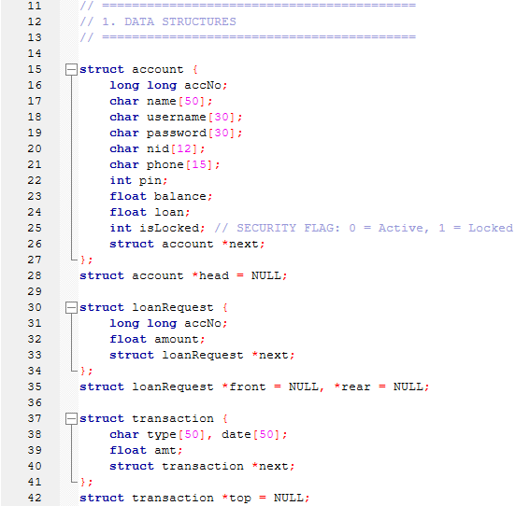
Figure 3.1: Core Data Structures
The struct account represents the main entity of the system, encapsulating all customer and financial information along with a self-referential pointer to form a singly linked list. The global pointer head serves as the starting point of the list.
The struct loanRequest implements a queue (FIFO) using front and rear pointers to manage pending loan applications.
The struct transaction forms a stack (LIFO) using the top pointer, enabling the display of recent transactions in reverse chronological order.
These structures provide dynamic memory management and support essential banking operations in the console-based application.
    - UTILITY FUNCTIONS
Several utility functions have been implemented to enhance user interface, control program flow, and improve overall readability of the system.
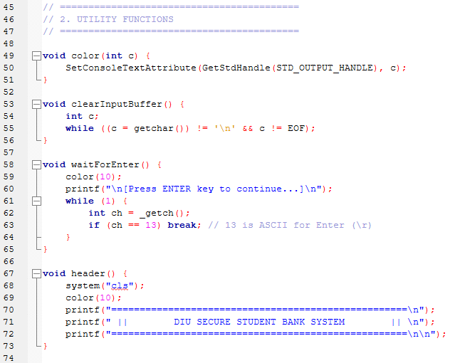
Figure 3.2: Utility Functions
The utility functions provide essential support for the console-based interface. The color() function changes console text color for better visual feedback. The clearInputBuffer() function prevents input skipping issues after scanf(). The waitForEnter() function pauses program execution until the user presses the ENTER key. Finally, the header() function clears the screen and displays the project banner consistently across all screens.
These helper functions improve user experience and maintain a clean, professional appearance throughout the application.
    - CORE MEMORY & QUEUE/STACK
This section implements fundamental operations for searching accounts and managing queue and stack data structures.
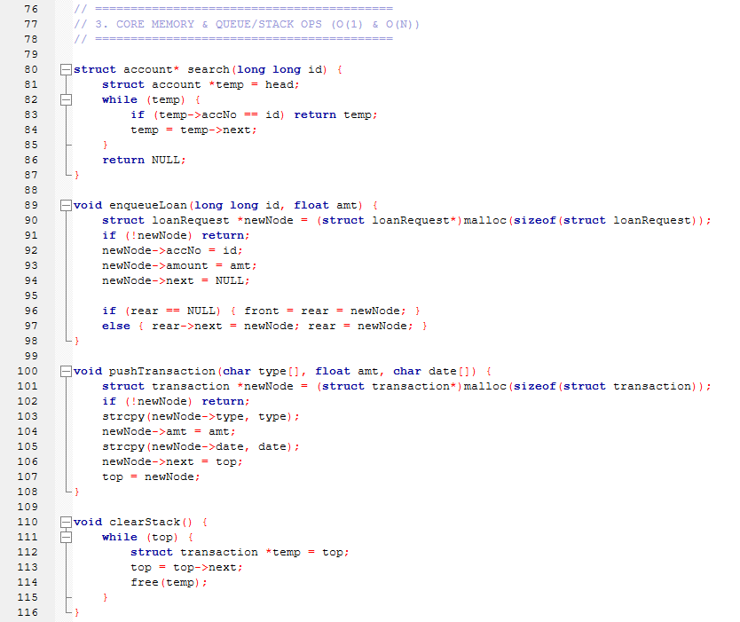
Figure 3.3: Core Memory, Queue and Stack Operations
The search() function performs a linear search on the singly linked list to locate an account by its account number, with O(N) time complexity in the worst case.
The enqueueLoan() function adds new loan requests to the rear of the queue, maintaining First-In-First-Out (FIFO) order for pending loan processing.
The pushTransaction() function inserts transaction records onto the top of the stack, enabling Last-In-First-Out (LIFO) retrieval for displaying recent transaction history.
The clearStack() function deallocates all nodes in the transaction stack to prevent memory leaks before loading new transaction data.
These operations form the foundation for efficient account retrieval and dynamic management of loans and transactions.
    - VALIDATION & SECURITY PROTOCOLS
To ensure data integrity and system security, several validation and security functions have been implemented.
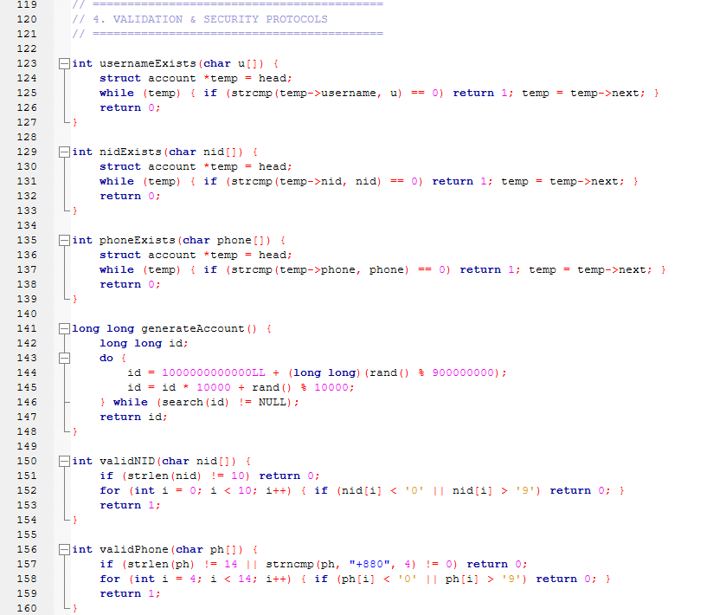
Figure 3.4: Validation and Security Functions Part 1
This part implements essential validation and uniqueness checking mechanisms. The functions usernameExists(), nidExists(), and phoneExists() detect duplicate entries during account creation. The generateAccount() function generates a unique 13-digit account number, while validNID() and validPhone() ensure proper format of National ID and phone number respectively.

This figure illustrates the implementation of data persistence using file handling, including secure saving and backward-compatible loading of account information.

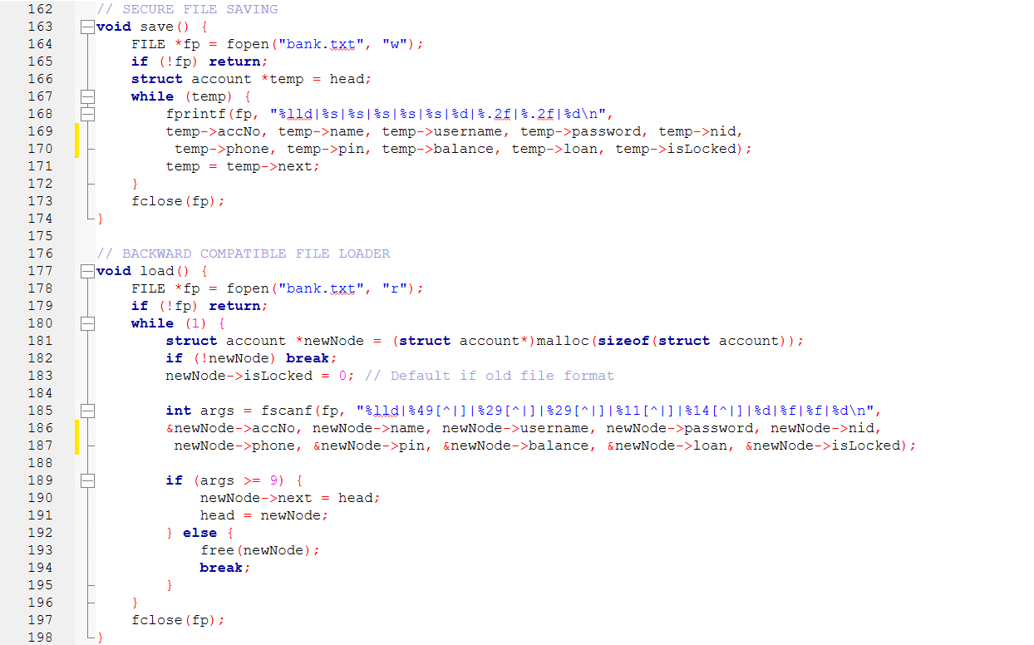
Figure 3.5: Validation and Security Functions Part 2
The save() function writes all account data from the linked list into the bank.txt file. It traverses each node and stores structured account details such as account number, personal information, PIN, balance, loan, and lock status using a delimiter-based format. This ensures that all user data is preserved even after program termination.
The load() function reconstructs the linked list by reading data from the same file during program startup. It dynamically allocates memory for each account and populates the fields using formatted input. Additionally, it maintains backward compatibility by assigning a default value to the isLocked field when loading older file formats. This guarantees data consistency and system stability across different versions.

This figure presents the implementation of transaction logging and secure PIN authentication mechanisms within the system.

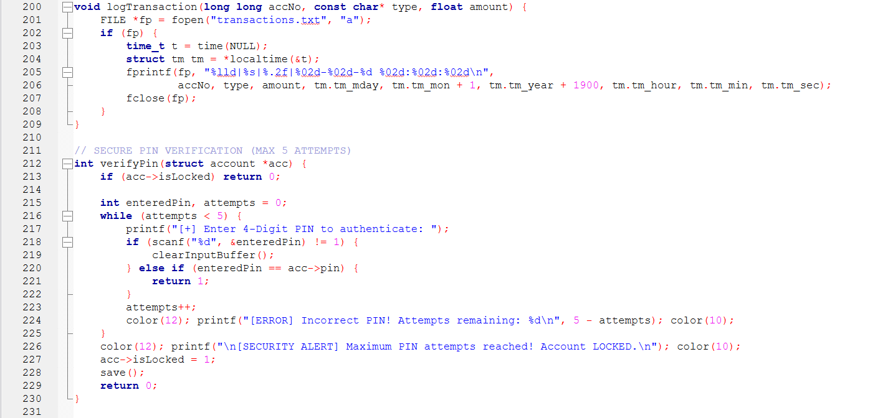
Figure 3.6: Validation and Security Functions Part 3
The logTransaction() function records each financial activity into the transactions.txt file. It captures essential details such as account number, transaction type, amount, and timestamp using system time functions, ensuring accurate transaction tracking and auditability.
The verifyPin() function enforces a secure authentication process before executing sensitive operations. It allows a maximum of five attempts for PIN entry. Upon successful verification, access is granted; otherwise, after exceeding the limit, the account is automatically locked by updating the isLocked flag and saving the status to persistent storage.

    - CORE BANKING FUNCTIONS (USER)
This part of the createAccount() function handles user input and basic validation.
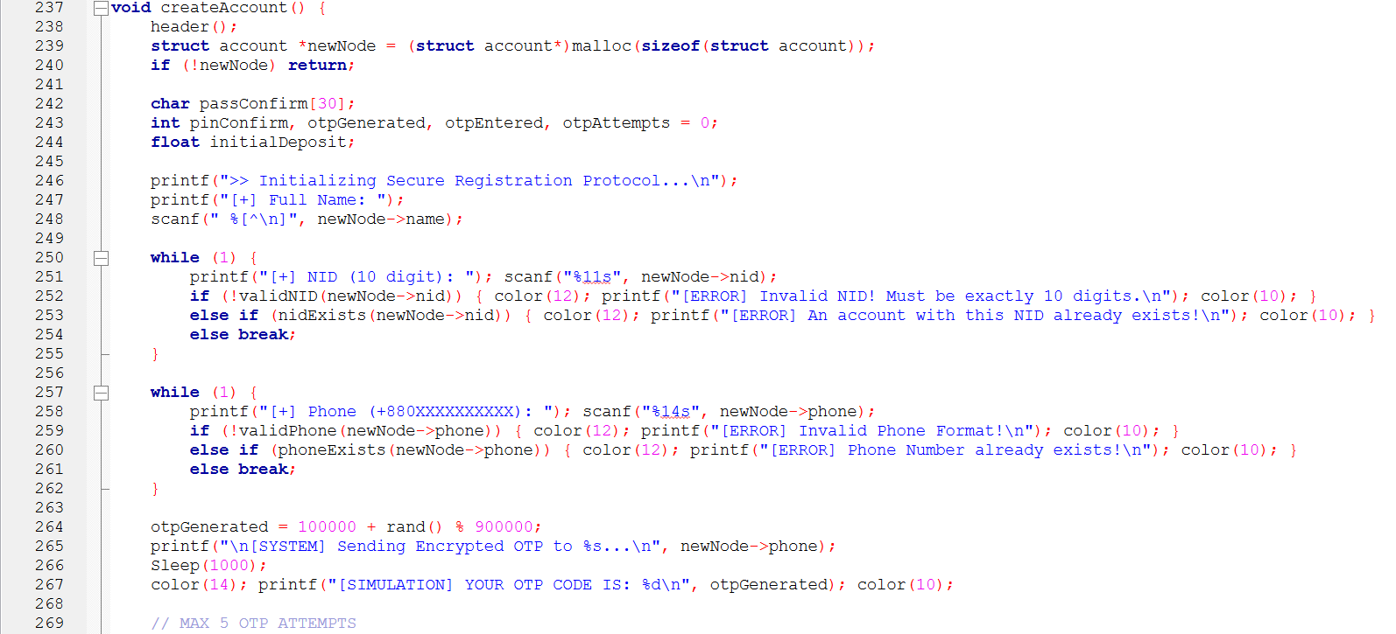
Figure 3.7: Initial Input and Validation in createAccount() Function
The function begins by allocating memory for a new account node and initializing the secure registration protocol. It collects essential user information such as full name, National ID (NID), and phone number. Validation mechanisms are applied to ensure that the NID follows the required format and is unique within the system. Similarly, the phone number is validated for correct format and checked for duplication.
These validation steps ensure data integrity and prevent the creation of multiple accounts with the same identification information.

This part of the createAccount() function handles OTP verification and user credential setup.
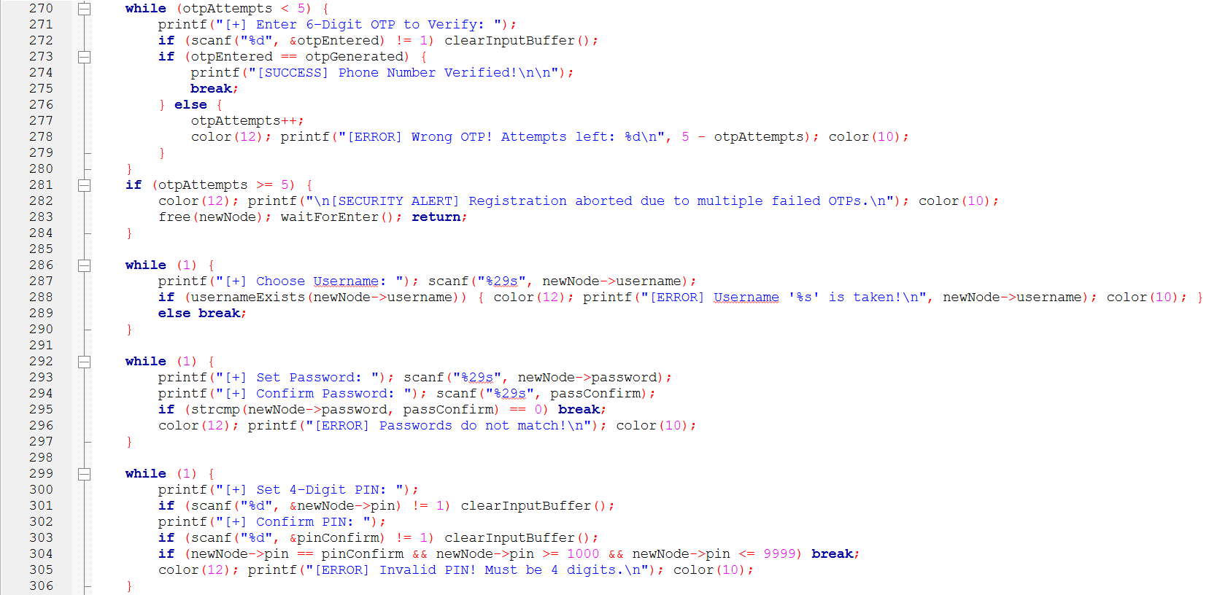
Figure 3.8: OTP Verification and Credential Setup in createAccount() Function
The function first verifies the OTP entered by the user within a maximum of five attempts. If the correct OTP is provided, the registration process continues; otherwise, after exceeding the limit, the process is terminated for security purposes.
After successful verification, the user is prompted to choose a unique username. The system checks whether the username already exists to avoid duplication. Then, the user sets a password, which must match the confirmation input to ensure accuracy.
Finally, the user is required to set a 4-digit PIN. The system validates the PIN format and ensures it is correctly confirmed. These steps ensure secure and reliable account setup.
This part of the createAccount() function handles initial deposit validation and final account creation.
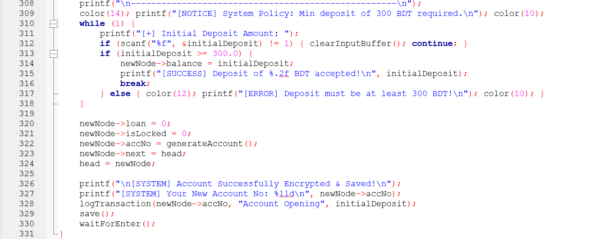
Figure 3.9: Initial Deposit and Final Account Creation in createAccount() Function
The function enforces a minimum deposit requirement of 300 BDT before creating an account. It continuously prompts the user until a valid amount is entered. Once the condition is satisfied, the deposit is accepted and assigned as the initial account balance.
After that, the system initializes default values such as loan amount and lock status. A unique account number is generated, and the new account is inserted into the linked list. Finally, the account details are saved to the file, and the transaction is logged for record-keeping.
These steps ensure proper account initialization, data persistence, and secure record management.

This part of the editAccount() function manages user account modification options, including phone number and password updates.
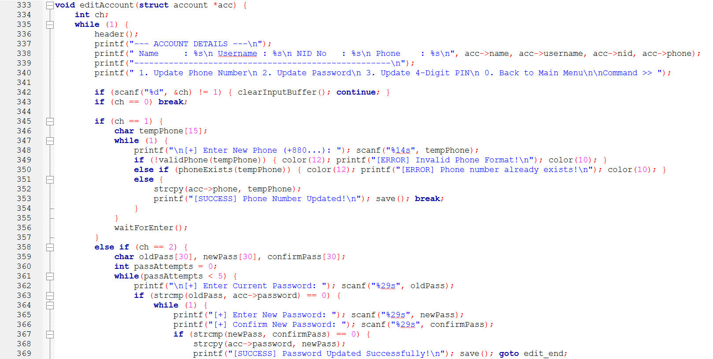
Figure 3.10: Phone and Password Update in editAccount() Function
The function first displays the current account details and provides a menu for selecting different update operations. When the user chooses to update the phone number, the system checks the new input for correct format and uniqueness before saving the change.
For password updates, the user must first enter the current password for verification. After successful authentication, the new password must be entered and confirmed correctly. Once validated, the updated password is stored and saved to the file.
These steps improve account security and ensure that personal information is updated in a controlled and validated manner.

This part of the editAccount() function handles PIN update and account security enforcement.
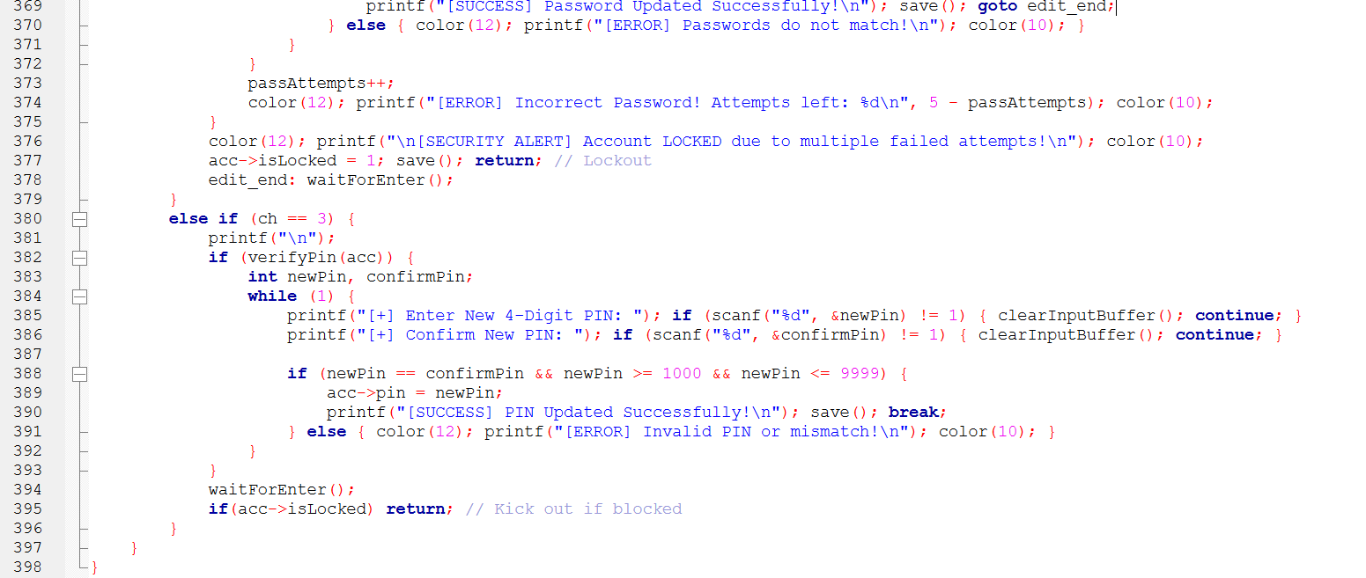
Figure 3.11: PIN Update and Security Lock Mechanism in editAccount() Function

The function allows the user to update their PIN after successful verification using the existing PIN. The new PIN must be a valid 4-digit number and must match the confirmation input before being updated. Once validated, the new PIN is saved securely.
Additionally, the function includes a security mechanism that limits incorrect password attempts. If the user exceeds the allowed number of attempts, the account is automatically locked by updating the isLocked flag. This prevents unauthorized access and ensures account safety.
These steps enhance both authentication control and overall system security.

This part of the system handles basic financial operations such as balance inquiry, deposit, and withdrawal.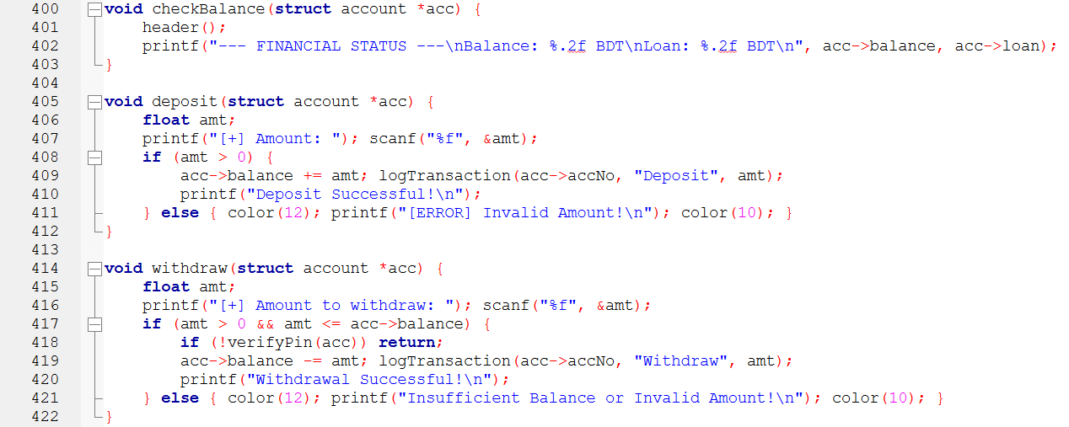
Figure 3.12: Balance Check, Deposit and Withdrawal in Banking Operations
The checkBalance() function displays the current balance and loan amount of the user in a clear format. The deposit() function allows users to add money to their account by entering a valid positive amount, which is then added to the balance and recorded in the transaction log.
The withdraw() function enables users to withdraw money securely. It checks whether the entered amount is valid and within the available balance. Before completing the transaction, the system verifies the user’s PIN to ensure security. If all conditions are satisfied, the amount is deducted and the transaction is logged.
These operations ensure accurate financial management and maintain secure transaction processing.

This part of the system manages both internal account transfers and external bank transfers.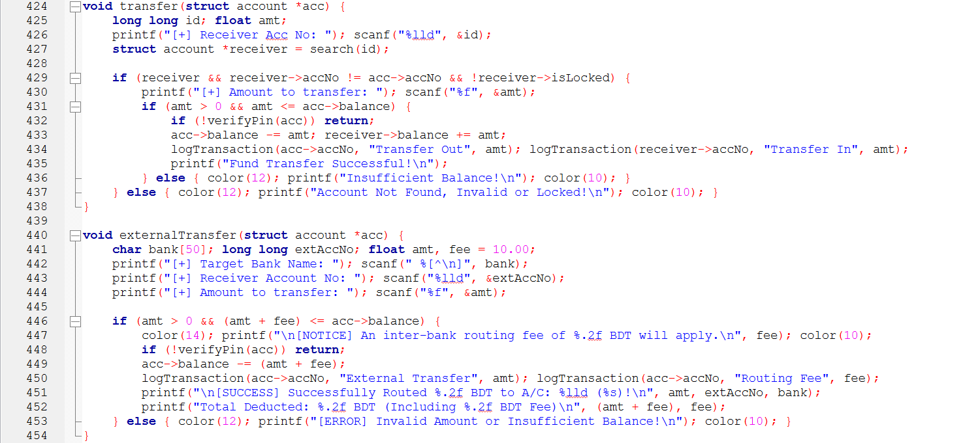
Figure 3.13: Internal and External Fund Transfer Operations
The transfer() function allows users to send money from one account to another within the system. It first checks whether the receiver account exists, is different from the sender’s account, and is not locked. After that, the entered amount is validated against the available balance, and PIN verification is required before completing the transfer. Once successful, the amount is deducted from the sender, added to the receiver, and both transactions are recorded.
The externalTransfer() function handles transfers to accounts in other banks. It collects the target bank name, external account number, and transfer amount. A fixed routing fee is applied, and the system verifies whether the total deduction is within the available balance. After PIN authentication, the amount and fee are deducted, and both records are stored in the transaction log.
These functions ensure secure fund movement and maintain proper transaction tracking for both internal and external transfers.

This part of the system handles loan request submission and repayment processing.
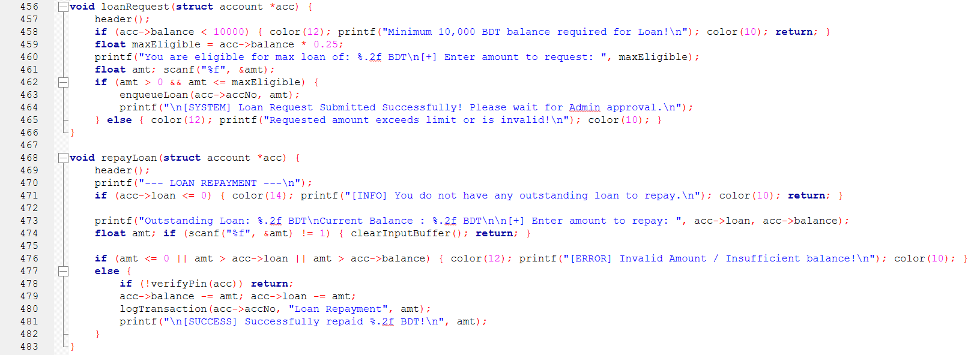
Figure 3.14: Loan Request and Repayment Operations
The loanRequest() function allows users to apply for a loan based on their account balance. It first checks whether the user meets the minimum balance requirement. Then, it calculates the maximum eligible loan amount and validates the requested amount before adding it to the loan request queue for admin approval.
The repayLoan() function enables users to repay their outstanding loan. It verifies whether a loan exists and ensures that the repayment amount is valid and within the available balance. Before completing the transaction, PIN verification is required for security. Once approved, the repayment amount is deducted from both the balance and loan, and the transaction is recorded.
These operations ensure controlled loan management and secure repayment handling within the system.

This part of the system handles retrieval and display of transaction history.
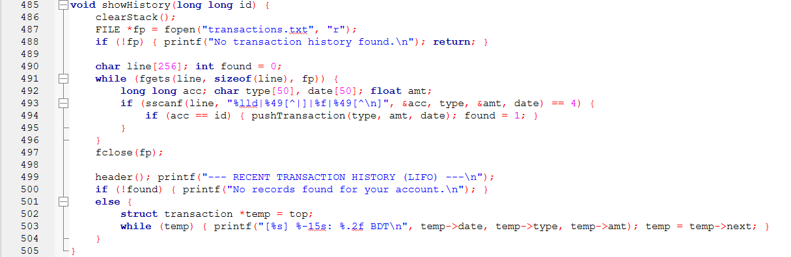
Figure 3.15: Transaction History Display using Stack (showHistory() Function)
The showHistory() function reads transaction records from the transactions.txt file and filters data based on the user’s account number. Matching transactions are pushed into a stack to maintain LIFO (Last-In-First-Out) order.
Before loading new data, the existing stack is cleared to prevent duplication. If no records are found, the system displays an appropriate message. Otherwise, the transactions are displayed starting from the most recent entry.
This approach ensures efficient transaction tracking and provides users with a clear view of their recent activities.

This part of the system manages the main user interface and controls all user operations.
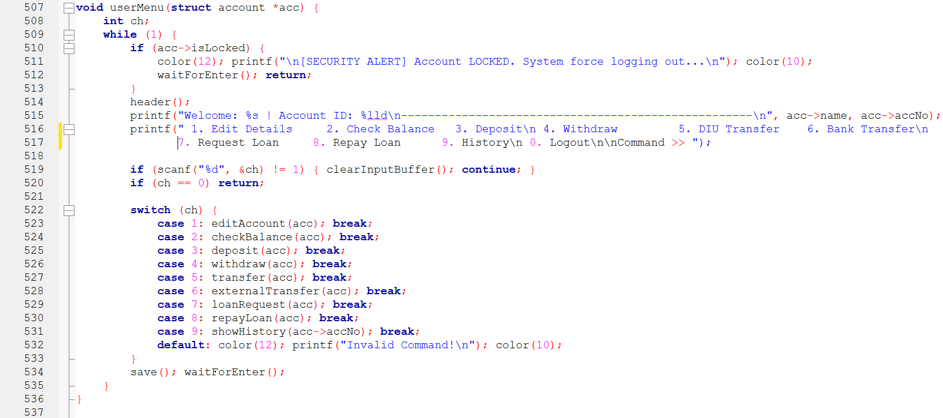
Figure 3.16: User Menu and Operation Control (userMenu() Function)
The userMenu() function displays a structured menu with all available banking operations such as account editing, balance checking, deposit, withdrawal, transfer, loan request, repayment, and transaction history. It continuously runs in a loop, allowing the user to perform multiple operations until logout.
Before showing the menu, the function checks whether the account is locked. If the account is locked, the system automatically logs the user out for security reasons. Based on user input, a switch statement is used to call the appropriate function for each operation.
After each operation, the system saves updated data and waits for user confirmation before continuing. This ensures smooth navigation, proper control flow, and secure handling of user activities.

    - LOGIN & RECOVERY PROCEDURES
This part of the system handles user login and initial authentication.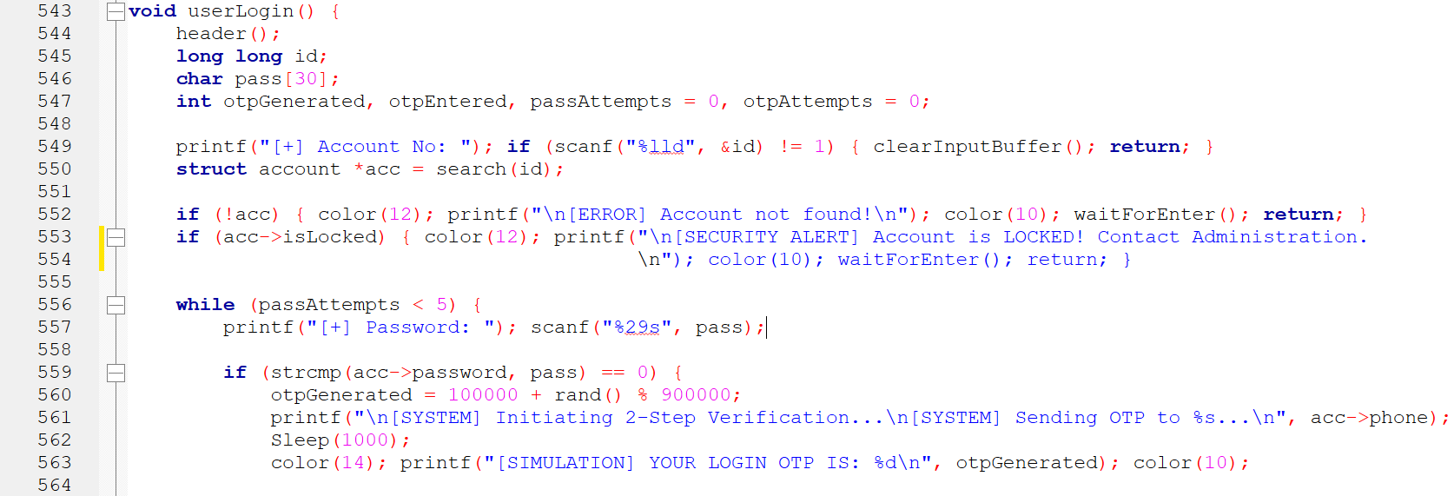
Figure 3.17: User Login and Initial Authentication (userLogin() Function)
The userLogin() function begins by taking the account number as input and searching for the corresponding account in the system. It checks whether the account exists and whether it is locked. If the account is not found or is locked, the system displays an appropriate message and stops the login process.
If the account is valid, the function allows the user to enter the password with a limited number of attempts. Upon successful password verification, the system generates a one-time password (OTP) and initiates a two-step verification process by sending the OTP to the registered phone number.
This approach ensures secure access by combining password authentication with OTP-based verification.

This part of the userLogin() function handles OTP verification and security enforcement during login.
Figure 3.18: OTP Verification and Account Locking in userLogin() Function
After successful password verification, the system requires the user to enter a one-time password (OTP) within a limited number of attempts. If the correct OTP is provided, the user is successfully logged in and redirected to the main user menu.
If the user fails to enter the correct OTP within the allowed attempts, the system triggers a security alert and locks the account by updating the isLocked flag. Similarly, repeated incorrect password attempts also result in account locking.
These mechanisms ensure strong authentication and protect the system from unauthorized access attempts.

This part of the system handles account recovery and password reset functionality.
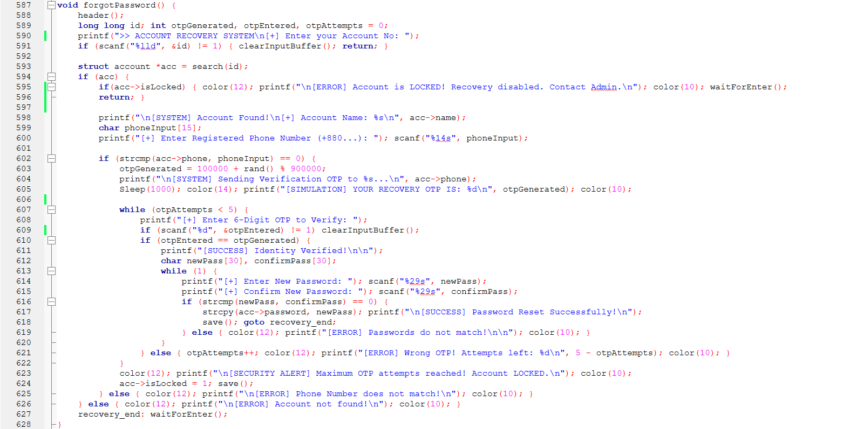
Figure 3.19: Password Recovery and OTP Verification (forgotPassword() Function)
The forgotPassword() function allows users to recover their account by entering the account number and verifying their registered phone number. If the account exists and is not locked, the system sends an OTP to the user for identity verification.
The user must enter the correct OTP within a limited number of attempts. Upon successful verification, the user is allowed to set a new password, which must match the confirmation input before being updated. If the OTP verification fails multiple times, the account is automatically locked for security reasons.
These steps ensure a secure and reliable password recovery process while preventing unauthorized access.

    - ADMIN FUNCTIONS
This part of the system manages administrative operations and system control.
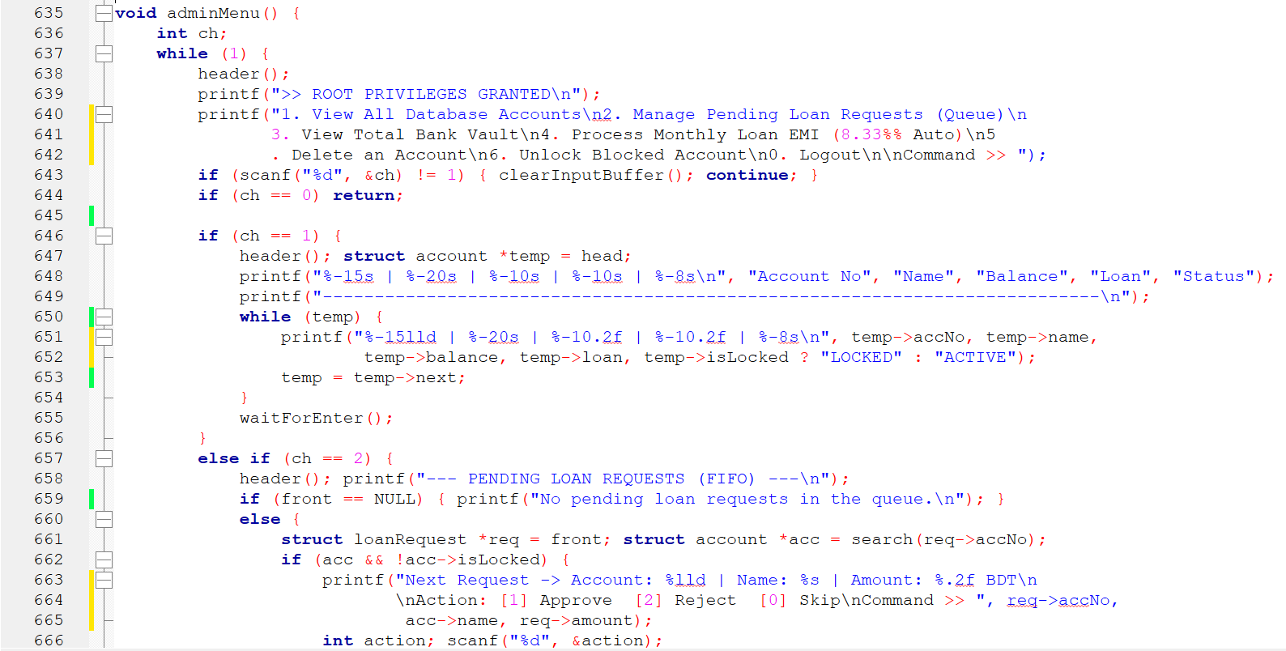
Figure 3.20: Admin Panel and Account Management (adminMenu() Function)
The adminMenu() function provides a centralized control panel for the administrator with multiple
management options. It displays a menu that allows viewing all accounts, managing pending loan
requests, checking total bank balance, processing monthly loan EMI, deleting accounts, and
unlocking blocked accounts.
When viewing all accounts, the system traverses the linked list and displays account details such as
account number, name, balance, loan amount, and status. For loan management, it processes
requests from the queue in FIFO order, allowing the admin to approve or reject each request.

This function ensures efficient system monitoring and gives the administrator full control over user
accounts and financial operations.

This part of the adminMenu() function handles loan approval, financial overview, and monthly EMI
processing.
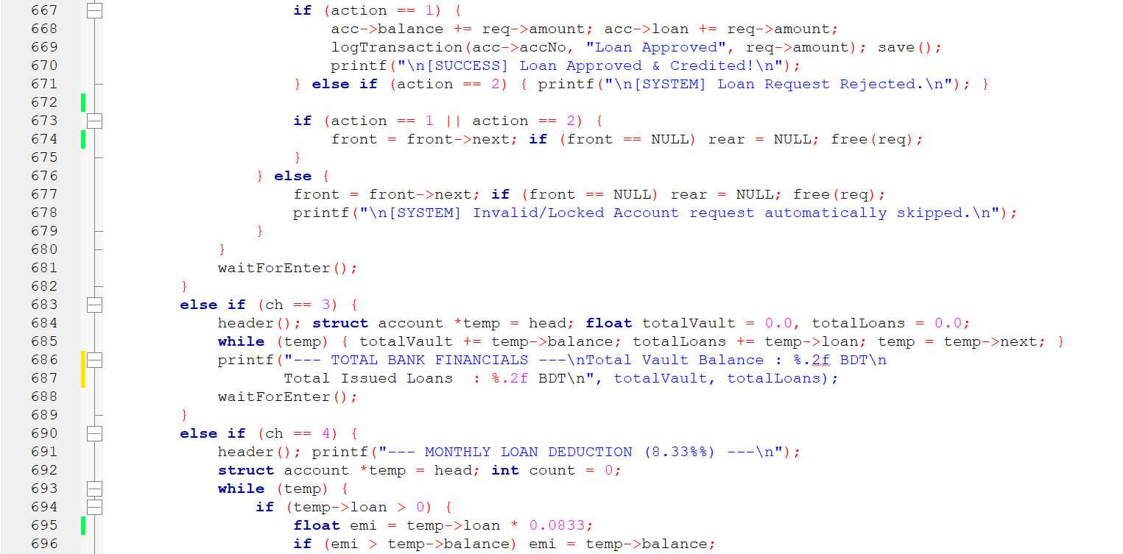
Figure 3.21: Loan Approval, Financial Summary and EMI Processing in adminMenu() Function
The function allows the administrator to approve or reject pending loan requests. When a loan is approved, the requested amount is added to both the user’s balance and loan, and the transaction is recorded. The processed request is then removed from the queue to maintain proper flow.
It also calculates the total bank vault balance and total issued loans by traversing all accounts. This provides an overall financial summary of the system.
Additionally, the function includes a monthly EMI processing feature, where a fixed percentage of the loan is deducted from each account with an active loan. If the balance is insufficient, the system deducts the maximum possible amount.
These operations ensure efficient loan management and accurate financial monitoring by the administrator.

This part of the adminMenu() function handles EMI completion and account deletion operations.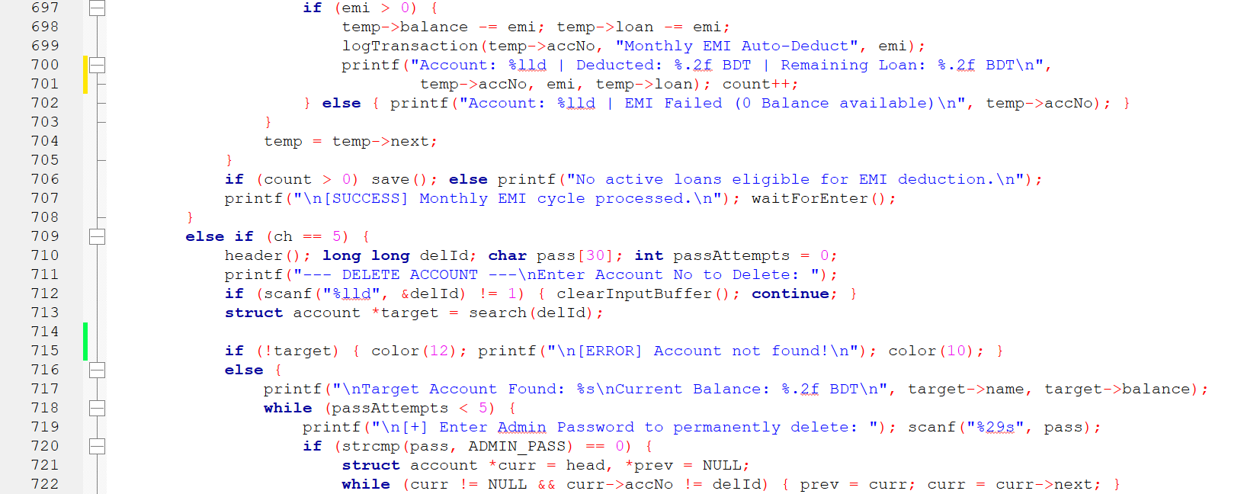
Figure 3.22: EMI Completion and Account Deletion in adminMenu() Function
The function completes the EMI processing by deducting the calculated installment from the account balance and reducing the loan amount accordingly. Each transaction is recorded, and a summary message is displayed after processing all eligible accounts. If no accounts qualify, the system provides an appropriate notification.
Additionally, the function allows the administrator to permanently delete an account. It first verifies the target account and then requires admin password authentication for security. Once verified, the account is removed from the linked list and the updated data is saved.
These operations ensure proper loan management and secure administrative control over account data.

This part of the adminMenu() function handles secure account deletion and account unlocking operations.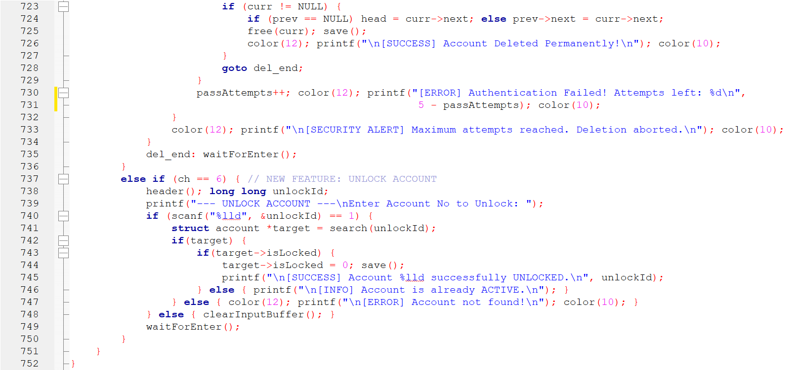
Figure 3.23: Secure Account Deletion and Unlock Feature in adminMenu() Function
The function ensures secure account deletion by requiring admin password verification before removing an account. If authentication is successful, the account node is deleted from the linked list, memory is freed, and the updated data is saved. If multiple incorrect attempts occur, the deletion process is aborted to maintain security.
In addition, the function provides an account unlock feature. The administrator can search for a locked account and reset its isLocked status, making it active again. Proper validation is applied to ensure the account exists before performing the operation.
These features provide strong administrative control and enhance overall system security and maintainability.

This part of the system handles administrator login and access control.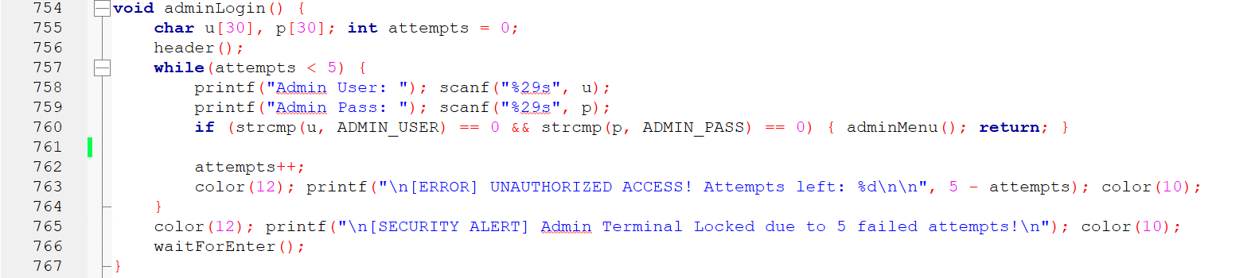
Figure 3.24: Admin Authentication and Security Control (adminLogin() Function)
The adminLogin() function verifies administrator credentials by comparing the entered username and password with predefined values. If the credentials are correct, the system grants access to the admin panel.
To enhance security, the function limits login attempts to a maximum of five. For each failed attempt, an error message is displayed showing the remaining attempts. If the limit is exceeded, the system locks the admin terminal and prevents further access.
This mechanism ensures restricted administrative access and protects the system from unauthorized usage.

    - MAIN ENTRY
This part of the system controls the overall program flow and user navigation.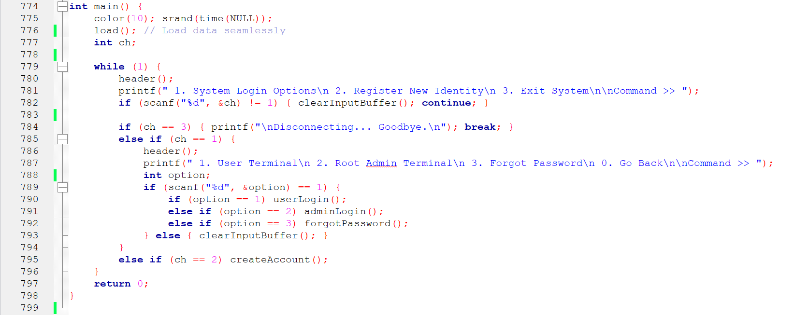
Figure 3.25: Main Function and System Flow Control (main() Function)
The main() function initializes the system by setting the console environment and loading previously saved data from the file. It then enters a continuous loop to display the main menu, allowing users to choose between login, account registration, or exiting the system.
If the user selects the login option, a secondary menu is shown where the user can access the user panel, admin panel, or password recovery system. Based on the selected option, the corresponding function is called.
This structure ensures smooth navigation, organized control flow, and proper interaction between different system modules.

Implementation Summary

The implementation of the DIU Secure Student Bank System successfully integrates multiple data structures and security mechanisms to simulate a real-world banking environment. Core functionalities such as account management, transaction processing, loan handling, and administrative control have been effectively implemented using linked list, queue, and stack structures.
Strong security features including password verification, PIN authentication, OTP-based validation, and account locking ensure safe user interaction. File handling is used to maintain data persistence, allowing the system to store and retrieve information efficiently.
Overall, the system provides a structured, secure, and user-friendly platform for performing banking operations, demonstrating both practical implementation skills and proper use of fundamental programming concepts.

- Performance Analysis
The overall time complexity of the system operations—such as account search, insertion, and deletion—is O(n), as these processes require sequential traversal of a linked list structure. Similarly, the space complexity is O(n), since the system dynamically allocates memory for accounts, loan requests, and transaction records, resulting in linear growth proportional to the number of stored entities.
- Results and Discussion
This section presents the outcomes of the implemented Student Bank Management System and provides an analysis of its performance. The results demonstrate how effectively the system handles core banking operations such as account creation, authentication, transactions, and data management. Furthermore, this section discusses the system’s efficiency, security mechanisms, and overall functionality based on testing and practical execution.
Before performing system operations, the main interface (home page) of the Student Bank Management System is displayed. 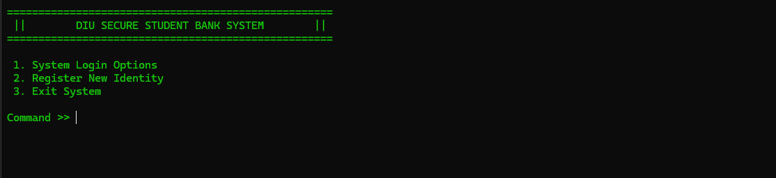
Figure 3.26: System Home Page
This interface provides users with different options such as login, registration, and system exit, serving as the entry point of the application.

After accessing the main interface, the “Register New Identity” operation was executed to evaluate the account creation functionality of the system. This process demonstrates how the system securely collects user information and performs multiple validation steps before creating a new account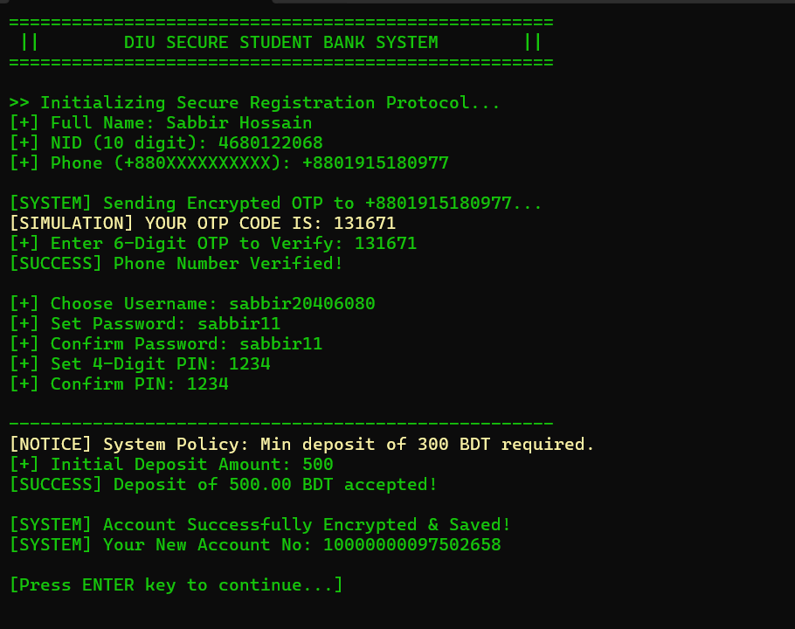
Figure 3.27: DIU Secure Student Bank System Registration Process

The registration process begins with the collection of essential user details such as full name, National ID (NID), and phone number. The system validates the input data to ensure correct formatting and uniqueness.
A secure OTP-based verification mechanism is then applied to confirm the user’s identity, enhancing system security. After successful verification, the user is required to set a username, password, and a 4-digit PIN with confirmation checks.
Additionally, the system enforces a minimum initial deposit policy to comply with banking requirements. Once all validations are successfully completed, the account information is securely stored, and a unique account number is generated automatically.
The results confirm that the system performs the registration process efficiently while maintaining data integrity, validation accuracy, and strong security measures.

Following the account registration process, the system provides a login interface that allows users to access different system modules based on their roles. This step evaluates how effectively the system manages user access and navigation.

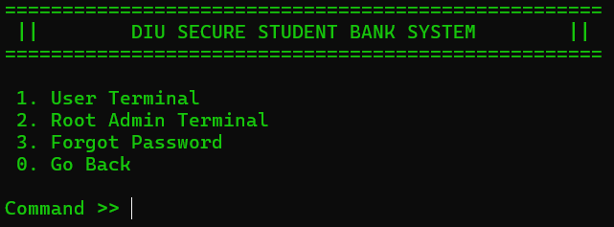
Figure 3.28: System Authentication and Access Control Interface
The login interface presents multiple options, including User Terminal, Root Admin Terminal, and Forgot Password functionality. This design ensures that both regular users and administrators can access their respective system features securely.
Additionally, the inclusion of a password recovery option enhances usability by allowing users to regain access in case of forgotten credentials. The structured menu system improves navigation and ensures smooth transition between different system modules.
The results demonstrate that the system successfully separates user roles and provides a clear and secure access mechanism.

Upon selecting the User Terminal option, the system prompts the user to enter their unique Account Number followed by their secure Password. Once these credentials are provided, the program executes a background verification against the stored data in the bank.txt file to ensure the identity is valid. After the password is confirmed, a Two-Step Verification is triggered, where the user must enter a 6-digit OTP to successfully grant access. Once all security layers are cleared, the user is redirected to their personal User Dashboard, where they can manage their balance, perform transfers, and view their transaction history.
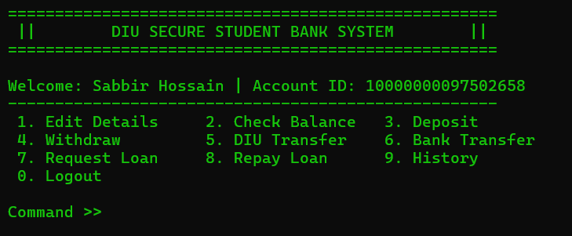
Figure 3.29: User Dashboard and Banking Operations Interface

The User Dashboard represents the core operational interface for registered students, providing a personalized experience after a successful login. This interface displays the user's name and unique Account ID at the top, followed by a comprehensive menu of nine banking functions. These features allow the user to manage their profile through Edit Details, perform financial transactions like Deposits, Withdrawals, and Fund Transfers, and manage credit services through Loan Requests and Repayments. Additionally, the dashboard offers a History option to track past transactions and a secure Logout command to terminate the session, ensuring a complete and efficient student banking experience.

Selecting option "1" triggers the "Edit Details" module, which allows the user to view their current profile information and provides options to securely update their registered phone number, account password, or 4-digit PIN.
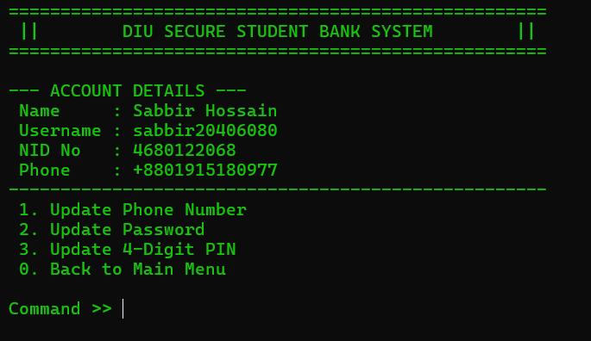Figure 3.30: Account Profile Details and Management Interface

The Account Details interface provides a comprehensive view of the user's stored profile information, displaying their Full Name, Username, National ID (NID) number, and registered Phone Number. This screen acts as a management console where users can choose to modify their sensitive data through three primary update options. By selecting the corresponding commands, users can update their Phone Number, change their Login Password, or reset their 4-digit PIN to ensure continued account security. The interface is designed to keep the user informed of their current status while providing a structured pathway to return to the main dashboard via the Back to Main Menu option.

Back to Main Menu and Selecting option "2" from the dashboard triggers the "Check Balance" function.
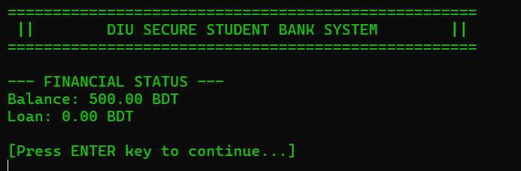
Figure 3.31: Real-time Financial Status and Balance Inquiry Interface
The Financial Status interface is a dedicated display module that provides users with an immediate overview of their account's fiscal standing. Upon selecting the balance check option, the system retrieves and presents the user's current Available Balance and any Outstanding Loan amounts, denominated in BDT. This screen ensures transparency by allowing students to monitor their funds and debt status in real-time. Additionally, it features a user-friendly navigation prompt, requiring the user to press the ENTER key to safely return to the main dashboard after reviewing their financial information.

Press ENTER key to continue and Selecting option "3" from the user dashboard initiates the "Deposit" function.
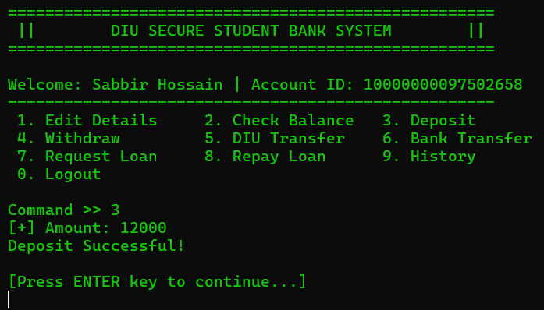
Figure 3.32: Successful Execution of Cash Deposit Transaction
This interface demonstrates the active execution of the deposit module within the User Dashboard. In this scenario, the user selected command "3" and entered an amount of 12000 BDT to be added to their account. The system processed the request instantly, displaying a "Deposit Successful!" confirmation message to notify the user that the funds have been safely credited. This interaction highlights the system's ability to handle large transactions efficiently and provides immediate visual feedback, requiring the user to press the ENTER key to proceed back to the main menu.

Press ENTER key to continue and Selecting option "4" from the dashboard initiates the "Withdraw" function.
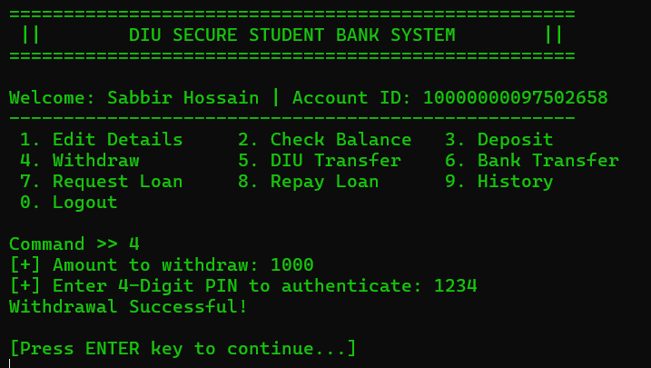
Figure 3.33: Authenticated Cash Withdrawal Process

This figure illustrates the step-by-step execution of the Withdrawal process within the system. After selecting command "4", the user is prompted to enter the desired amount, which in this instance is 1000 BDT. To ensure account security, the system mandates a 4-Digit PIN authentication before finalizing the transaction. Upon entering the correct PIN (1234), the system displays a "Withdrawal Successful!" confirmation, indicating that the funds have been debited from the account. The process concludes with a prompt for the user to press the ENTER key to return to the dashboard.

Press ENTER key to continue and Selecting option "5" from the dashboard activates the "DIU Transfer" module, which allows the user to send money directly to another student's account within the same system by providing the recipient's Account ID and the desired transfer amount.

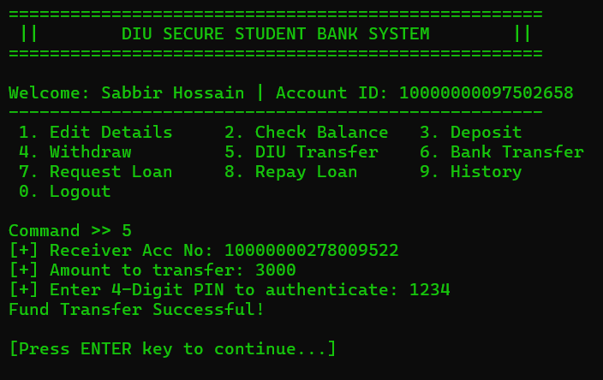
Figure 3.34: Intra-System Fund Transfer Process (DIU Transfer)

This figure demonstrates the DIU Transfer feature, which enables seamless money transfers between accounts within the system. After selecting command "5", the user enters the Receiver's Account Number and the specific amount to be sent, which is 3000 BDT in this case. To maintain high security, the system requires the sender to authenticate the transaction with their 4-Digit PIN. Once the correct PIN is verified, the system displays a "Fund Transfer Successful!" message, confirming that the amount has been instantly debited from the sender's account and credited to the recipient. The user is then prompted to press ENTER to return to the dashboard.

Press ENTER key to continue and Selecting option "6" from the dashboard initiates the "Bank Transfer" module, which allows the user to transfer funds to external bank accounts by providing the necessary banking details and the transfer amount.
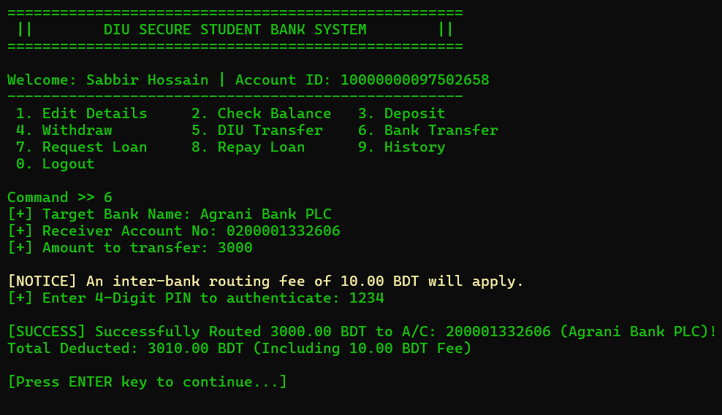
Figure 3.35: Inter-Bank Fund Transfer with Routing Fee Interface

This figure illustrates the Bank Transfer feature, which allows users to send funds to external banking institutions. After selecting command "6", the user specifies the Target Bank Name (e.g., Agrani Bank PLC), the Receiver's Account Number, and the amount to be transferred. A unique aspect of this module is the automatic notification of an inter-bank routing fee (10.00 BDT), which is added to the total transaction cost. To authorize the transfer of 3000 BDT, the user must provide their 4-Digit PIN. Upon successful authentication, the system confirms the routing and displays the total deducted amount (3010.00 BDT), ensuring full transparency regarding service charges before returning to the dashboard.

Press ENTER key to continue and Selecting option "7" from the dashboard opens the "Request Loan" module, which allows users to apply for a student loan by specifying the required amount, subject to the system's approval criteria and credit limits.
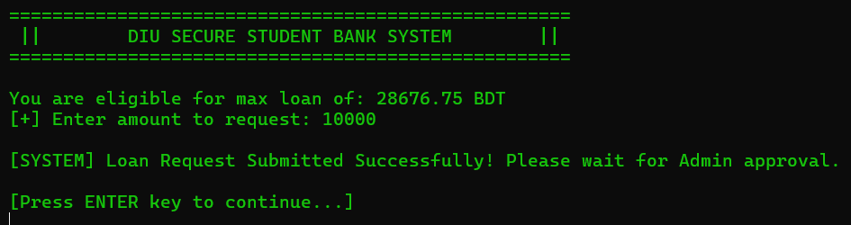
Figure 3.36: Student Loan Application and Eligibility Verification
This figure illustrates the Loan Request process within the student terminal. Based on the user's account history and balance, the system automatically calculates and displays the maximum eligible loan amount (e.g., 28676.75 BDT). The user then enters their desired amount, as seen in the example where 10,000 BDT is requested. Upon submission, the system provides a confirmation message stating, "Loan Request Submitted Successfully!" and informs the user that the request is now pending Admin approval. This ensures that while students can apply for financial assistance, the final disbursement is controlled by the bank's administration to maintain financial security.
Press ENTER key to continue and Selecting option "8" from the dashboard opens the "Repay Loan" module, which allows users to pay back their outstanding loan amounts directly from their current account balance to clear their debt.
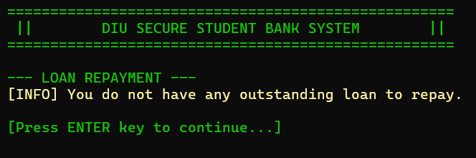
Figure 3.37: Loan Repayment Status Verification

This interface displays the Loan Repayment status when a user attempts to access the repayment module. In this scenario, the system performs a real-time check on the user's debt records and provides an informative message stating, "You do not have any outstanding loan to repay." This validation ensures that users cannot perform unnecessary transactions if they do not have a pending balance. The clear, concise notification helps maintain a smooth user experience, requiring the user to simply press the ENTER key to return to the main dashboard.

Press ENTER key to continue and Selecting option "9" from the dashboard opens the "Transaction History" module, which allows the user to view a detailed record of all their previous activities, including deposits, withdrawals, and fund transfers, ensuring full transparency of their account movements.

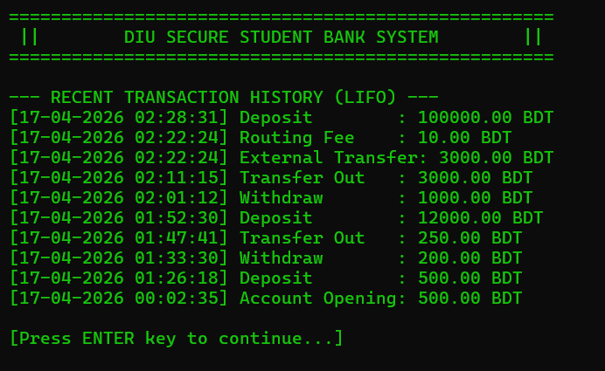
Figure 3.38: Detailed Transaction History Log (LIFO Order)

This interface displays the Recent Transaction History of the user's account, organized in LIFO (Last-In, First-Out) order. It provides a comprehensive log of all financial activities, including the initial account opening, deposits, withdrawals, internal transfers, and external bank transfers with associated routing fees. Each entry is clearly timestamped with the exact date and time, showing the type of transaction and the specific amount in BDT. This feature serves as a digital passbook, allowing users to track their spending and saving patterns with full transparency before pressing the ENTER key to exit the history view.

Press ENTER key to continue and log out the account. After enter System Login Options and Accessing the "Root Admin Terminal" (Option 2) is strictly restricted to authorized administrators only. To enter the Admin Portal, the administrator must provide their specific admin username and secure password; once the credentials are verified, the system unlocks the management interface for administrative tasks.

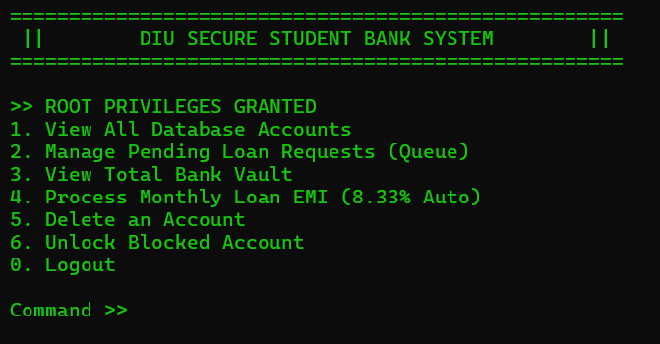
Figure 3.39: Root Admin Control Panel with Administrative Privileges

This figure represents the Root Admin Portal, which is accessible only after successful administrator authentication. The screen displays the message "ROOT PRIVILEGES GRANTED," indicating that the administrator now has full control over the system's backend. This control panel provides several high-level administrative options, such as viewing all database accounts, managing pending loan requests, monitoring the total bank vault, and processing monthly loan EMIs. Additionally, the admin can perform critical security tasks like deleting accounts or unlocking blocked ones. This interface is the central hub for maintaining the overall integrity and operational flow of the DIU Secure Student Bank System.

By selecting option "1" from the Admin Control Panel, the administrator can access the "View All Database Accounts" module. This feature displays a comprehensive list of all registered student accounts, including their sensitive details, balances, and account statuses, allowing the admin to monitor every user within the system's database.

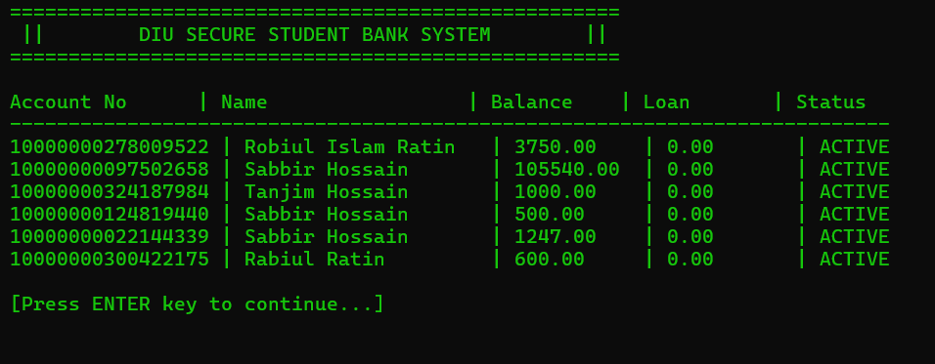
Figure 3.40: Administrator View of All Database Accounts
This figure illustrates the Database Overview screen, accessible only to the Root Admin. It presents a structured table containing the details of all registered users in the system. The table includes critical information such as Account Number, Account Holder's Name, Current Balance, Outstanding Loan Amount, and Account Status (e.g., ACTIVE). This high-level view allows the administrator to perform audits, monitor user balances, and ensure the overall health of the banking database. The data is neatly aligned in columns to ensure readability for the admin before they press the ENTER key to return to the control panel.

Selecting option "2" from the Admin Control Panel opens the "Manage Pending Loan Requests" module. This interface allows the administrator to review all incoming loan applications in a queue; the admin has the authority to either approve and accept these requests—instantly crediting the amount to the student's account—or reject them based on the bank's policies.
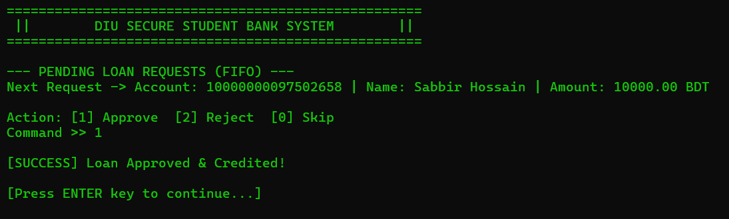
Figure 3.41: Admin Interface for Pending Loan Approval (FIFO Queue)

This figure demonstrates the administrator's workflow for managing loan applications through a FIFO (First-In, First-Out) queue. The interface displays the next pending request, showing the applicant's Account Number, Name, and the requested Loan Amount (e.g., 10,000.00 BDT). The administrator is provided with three distinct actions: Approve (1), Reject (2), or Skip (0). In this instance, the admin selects command "1", resulting in a "[SUCCESS] Loan Approved & Credited!" notification. This indicates that the requested funds have been successfully added to the student's balance and the loan record has been updated in the database. The admin then simply presses ENTER to move to the next request in the queue.

Selecting option "3" from the Admin Control Panel allows the administrator to "View Total Bank Vault." This feature provides a high-level financial summary, showing the total liquid cash available in the system, the sum of all student deposits, and the total amount of outstanding loans, ensuring the administrator can monitor the bank's overall liquidity and financial health.

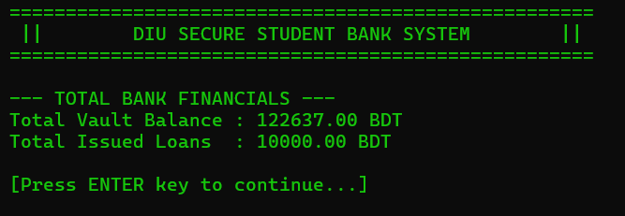
Figure 3.42: Total Bank Financials and Vault Overview

This interface provides the administrator with a high-level summary of the Total Bank Financials. It displays two critical metrics: the Total Vault Balance, which represents the cumulative liquid assets currently held within the system (e.g., 122,637.00 BDT), and the Total Issued Loans, which shows the sum of all outstanding debts owed by students (e.g., 10,000.00 BDT). This "Vault View" is essential for the admin to monitor the bank's overall capital and ensure that the institution maintains enough liquidity to cover withdrawals while tracking the scale of its lending operations. After reviewing these figures, the admin can press ENTER to return to the root menu.

Selecting option "4" from the Admin Control Panel initiates the "Process Monthly Loan EMI" function. This automated feature calculates and deducts the monthly installment (set at a fixed rate of 8.33%) from the accounts of all students with outstanding loans, ensuring systematic debt recovery and maintaining the bank's cash flow.
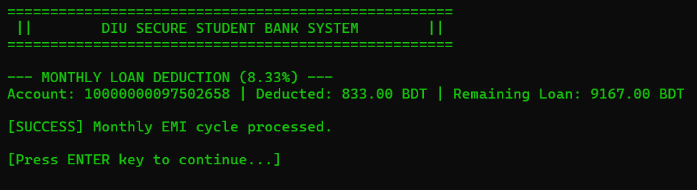
Figure 3.43: Automated Monthly Loan EMI Deduction Process
his figure illustrates the Monthly Loan Deduction system in action. When the administrator triggers this function, the system automatically applies a fixed 8.33% EMI rate to all active loans. The screen shows a specific transaction where 833.00 BDT was deducted from the student's account, leaving a Remaining Loan balance of 9,167.00 BDT. Upon completion, the system displays a "[SUCCESS] Monthly EMI cycle processed" message. This automated feature ensures that loan repayments are collected consistently across the entire database, reducing the need for manual entry and minimizing the risk of missed payments.

Selecting option "5" from the Admin Control Panel activates the "Delete an Account" module. This high-level administrative tool allows the admin to permanently remove a specific student account from the system database by entering the target account number. This feature is typically used for account closures or policy enforcement, ensuring the admin has full control over the user database.
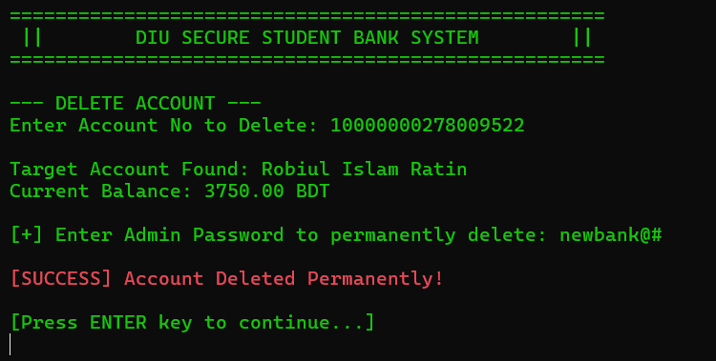
Figure 3.44: Secure Account Deletion Process via Admin Verification
This figure demonstrates the system's Secure Account Deletion workflow. To prevent accidental data loss, the process involves multiple steps: first, the administrator enters the specific Account Number to be deleted. The system then fetches and displays the Target Account details (e.g., Name and Current Balance) for final verification. To execute the permanent removal, the administrator must provide their Secret Admin Password as a secondary security layer. Upon correct entry, the system displays the message "[SUCCESS] Account Deleted Permanently!" in red, indicating that all records associated with that user have been purged from the database.

Press ENTER key to continue and By selecting option "6" from the Admin Control Panel, the administrator can access the "Unlock Blocked Account" feature. This critical security tool allows the admin to restore access for students whose accounts have been locked due to multiple incorrect log in attempts or security protocols. By entering the specific account number, the administrator can reset the account status to active, ensuring that the student can once again perform banking transactions securely.
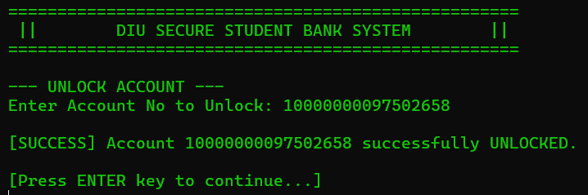
Figure 3.45: Admin Interface for Unlocking a Blocked User Account
This figure illustrates the administrative process of restoring access to a restricted account. Within the "UNLOCK ACCOUNT" module, the administrator is prompted to enter the specific Account Number that needs to be reactivated. Once the number is entered and verified, the system executes the command and displays a confirmation message: "[SUCCESS] Account [Account No] successfully UNLOCKED." This feature is crucial for maintaining user accessibility, allowing the admin to assist students who may have been locked out due to security reasons or incorrect login attempts, thereby ensuring continuous service availability.

Press ENTER key to continue and Log out Admin Account. Go to home page enter “1” after that By selecting option "3" , the user accesses the "Forgot Password" module. This feature is designed to help users recover or reset their account access; by following the system prompts and providing the necessary verification details, a user can securely change their old password and set a new one to regain entry to their account.
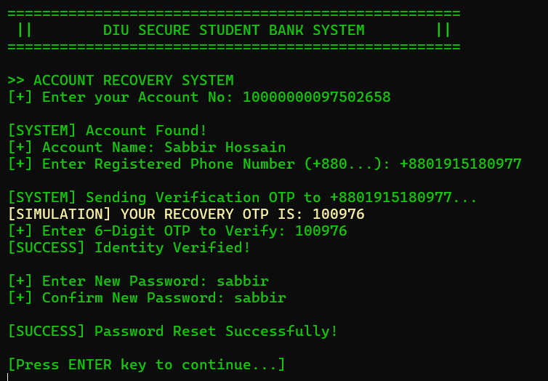
Figure 3.46: Multi-Step Account Recovery and Password Reset System
This figure illustrates the Account Recovery System, which provides a secure way for users to reset their passwords. The process begins with the user entering their Account Number, after which the system verifies the account and prompts for the Registered Phone Number. To ensure security, the system simulates sending a 6-digit OTP (One-Time Password) to the user's mobile device. Once the identity is confirmed with the correct OTP, the user is allowed to enter and confirm a New Password. Upon successful completion, the system displays a "[SUCCESS] Password Reset Successfully!" message, ensuring that the user can regain access to their account with updated credentials.

Overall, the implemented Student Bank Management System successfully demonstrates all core banking functionalities, including account registration, secure authentication, transaction processing, and administrative control. The system performs efficiently in handling user operations while maintaining data integrity and security through mechanisms such as OTP verification, PIN protection, and account lock features.
The results confirm that the system is reliable, user-friendly, and capable of simulating real-world banking operations within a controlled environment. However, certain limitations such as lack of multi-user support and online accessibility highlight areas for future improvement. Despite these limitations, the system effectively fulfills its intended objectives and provides a strong foundation for further development.

Chapter 4

Engineering Standards and Mapping

This chapter presents the engineering standards applied in the development of the system and provides a structured mapping of program outcomes and complex engineering problems. It also highlights the project’s impact on society, environment, and sustainability, along with team contributions and problem-solving approaches.

- Impact on Society, Environment and Sustainability

Impact on Life

This Student Bank Management System significantly improves students’ daily lives by integrating directly with university accounts. It allows students to pay tuition fees, hall fees, and transport fees easily from anywhere, eliminating the need to visit campus and stand in long queues. The system ensures faster and more reliable transactions, reducing uncertainty such as delayed payment confirmations. By providing secure authentication and real-time tracking, it enhances trust and convenience in financial activities. Additionally, it supports a fully digital campus experience, saving time and effort for students. Overall, this system promotes efficiency, accessibility, and modern financial management in student life.

Impact on Society & Environment

This system plays an important role in improving daily life by connecting banking services with university activities in one platform. It reduces the need for physical visits to campus or banks, which saves time and avoids crowd and hassle. Students can easily pay tuition, hall, and transport fees online, making the whole process faster and more convenient. The system also ensures secure and real-time transactions, which builds trust and reduces confusion about payments. From an environmental perspective, it reduces paper usage, lowers fuel consumption by minimizing travel, and helps decrease carbon emissions, contributing to a greener environment. Overall, it supports a simple, efficient, and modern lifestyle for students and society.

Ethical Aspects

This system follows important ethical principles by ensuring the privacy and security of user data through authentication methods like passwords and OTP verification. It promotes fairness by providing equal access to banking and payment services for all students without discrimination. The system also maintains transparency, as users can clearly track their transactions and financial activities. By reducing human involvement in transactions, it minimizes the chances of fraud, errors, and corruption. Additionally, it encourages responsible financial behavior among students by giving them better control over their money. Overall, the system supports ethical practices by ensuring security, fairness, transparency, and accountability.

Sustainability Plan

The sustainability of this system can be strengthened through structured collaboration between students and university administration. By officially integrating the platform into core activities such as tuition, hall, and transport fee payments, the system can ensure consistent and long-term usage. Strategic awareness campaigns, including orientation programs, campus events, and digital promotions, can further increase adoption among students. Continuous feedback collection and regular system updates will help maintain efficiency, security, and user satisfaction over time. In addition, training and support from the university will ensure proper usage and reliability of the system. Overall, a combination of institutional support, user engagement, and continuous improvement will ensure the system’s long-term sustainability and effectiveness.

- Project Management and Team Work

Table 4.1: Project Management and Team Work
Topic | Name
Topic Selection | Muhammad Tanjeem, MD. Sabbir Hossain Shamim, Robiul Islam Ratin, Ayasur Rahman Siddique Jidan, Tamim Jobayer
Requirement Analysis | Muhammad Tanjeem, MD. Sabbir Hossain Shamim, Tamim Jobayer, Ayasur Rahman Siddique Jidan, Robiul Islam Ratin
System Design | Muhammad Tanjeem, MD. Sabbir Hossain Shamim, Robiul Islam Ratin
System Implementation | Muhammad Tanjeem, MD. Sabbir Hossain Shamim
Test | Muhammad Tanjeem, MD. Sabbir Hossain Shamim, Robiul Islam Ratin
Report Writing | Muhammad Tanjeem, MD. Sabbir Hossain Shamim
Presentation Slide | Muhammad Tanjeem, MD. Sabbir Hossain Shamim, Robiul Islam Ratin, Ayasur Rahman Siddique Jidan, Tamim Jobayer

- Complex Engineering Problem

Mapping of Program Outcome

In this section, provide a mapping of the problem and provided solution with targeted Program Outcomes (PO’s).

Table 4.2: Justification of Program Outcomes
PO’ s | Justification
PO3 | This project demonstrates the ability to design and develop a structured banking solution tailored for student use. The system integrates multiple functional modules such as account creation, transaction processing, loan management, and security mechanisms. Efficient data structures like linked lists, queues, and stacks are used to ensure dynamic data handling and real-time operations. Additionally, user-friendly menus and modular functions are implemented to create a clear and organized system design that meets both functional and security requirements.
PO5 | This system uses modern programming tools and techniques such as file handling, OTP-based authentication, and structured data management to ensure efficiency and security. We also implemented core data structures like linked lists, stacks, and queues to handle real-time banking operations effectively. These tools were chosen to build a reliable, scalable, and practical system that reflects real-world banking applications.
PO9 | This project reflects effective teamwork and individual contribution throughout its development. Each member was responsible for specific tasks such as system design, implementation, testing, and documentation. Collaborative efforts ensured proper integration of modules like account management, transaction handling, and security features. Regular communication and coordination among team members helped in identifying issues, solving problems efficiently, and completing the project successfully within the given timeframe.

Complex Problem Solving

In this section, provide a mapping with problem solving categories. For each mapping add subsections to put rationale (Use Table 4.3). For P1, you need to put another mapping with

Chapter 4. Engineering Standards and Mapping 4.4. Complex Engineering Problem Knowledge profile and rational thereof.
Table 4.3: Mapping with complex problem solving.
EP 1  Dept of  Knowledge | EP 2  Range of Conflicting Require-ments | EP 3  Depth of  Analysis | EP 4  Familiarity  of Issues | EP 5  Extent of Applicable Codes | EP 6  Extent  Of Stake holder Involve-ment | EP 7  Inter-  dependence
√ | √ | Not Applicable | Not Applicable | Not Applicable | √ | Not Applicable

EP1: Our Student Bank Management System falls under EP1: Depth of Knowledge, because it required a broad and deep understanding of core engineering concepts. We used complex data structures such as linked lists, arrays, stacks, and queues, along with advanced functions and file handling to create a dynamic and secure system. These elements go beyond basic programming, requiring a strong grasp of engineering knowledge to manage real-world financial operations. Thus, this application of core concepts clearly fulfills EP1. The evidence for achieving EP1 is documented in Chapter 2, Requirement Analysis, Section 1.1, Overview of the project.

EP 2: The bank management system we developed is not the only solution in the world; there are multiple alternative approaches globally. Although the requirement is the same, the system could have been implemented using arrays, linked lists, or even trees. We had multiple options; however, we chose the linked list approach. We opted for linked lists because they allow dynamic sizing, efficient insertion and deletion, and flexible memory management. Thus, despite other possible solutions, we selected this method to best meet the bank management system’s needs. The evidence of this decision is documented in Chapter 2, Requirement Analysis, Section 1.1, Overview.

EP 6 : EP6, stakeholder involvement was vital for shaping our system. When we met with the bank officer, we presented our system, which used linked lists, arrays, stacks, and queues for different functionalities—like managing withdrawals, transactions, user portals, and loans. The officer gave us valuable feedback, suggesting that while the overall structure was sound, we could refine certain elements for better security or usability. However, they couldn’t provide all technical details due to security concerns. After the meeting, they gave us a formal signature acknowledging our consultation. This stakeholder input helped us ensure that our requirements were aligned with real-world needs. The evidence of this involvement is documented in Chapter 2, Requirement Analysis, Section 1.1, Overview.

Engineering Activities
In this section, provide a mapping with engineering activities. For each mapping add subsections to put rationale (Use Table 4.4).

Table 4.4: Mapping with complex engineering activities.
EA 1  Range of resources | EA 2  Level of Interaction | EA 3  Innovation | EA 4  Consequences for society and environment | EA 5  Familiarity
Not Applicable | Not Applicable | Not Applicable | Not Applicable | Not Applicable

Chapter 5

Conclusion

This chapter provides a concise overview of the implemented banking system, summarizing its core functionalities and overall performance. It also highlights the key limitations of the system and discusses potential areas for future improvement and enhancement.

Summar y

DIU SECURE STUDENT BANK SYSTEM (DSSBS) is a student bank management system designed to simplify and digitize financial activities for university students. It integrates banking services with university operations to make payments faster, easier, and more efficient.

Main Objective

The main objective of this system is to enable students to pay tuition, transport, and hall fees online. It also aims to provide instant payment confirmation and reduce the need for physical visits, thereby saving time and cost.

Key Features

The system includes several important features such as account creation, deposit and withdrawal, and fund transfer. It also maintains transaction history using a stack and manages loan requests using a queue. In addition, the system ensures security through password, OTP, and PIN authentication. It includes an account lock feature for multiple incorrect attempts and uses file handling for data storage.
The system is developed using important data structures such as linked lists for account management, queues for loan processing, and stacks for maintaining transaction history.

Problem & Solution

In the traditional system, students need to physically visit the campus to complete financial transactions. Payment confirmation delays often create problems in getting clearance, which leads to wastage of time and cost.
This system solves these problems by providing an online banking platform where students can make payments from anywhere. It ensures instant verification for quick clearance and integrates all systems such as accounts, transport, and hall management into one platform.

System Workflow

The system has two main users: the student (user) and the admin. First, the user logs into the system and performs banking operations such as deposit, withdrawal, or transfer. All transactions are stored in files for record-keeping. Security verification is ensured through OTP and PIN. The admin is responsible for managing loan requests and controlling the overall system.

Technologies Used

The system is implemented using the C programming language. It uses data structures such as linked lists, queues, and stacks. File handling is used for storing data in files like bank.txt and transactions.txt. Security is maintained using password, OTP, and PIN verification.

Advantages

This system offers several advantages, including saving time and cost, reducing physical crowd on campus, and ensuring secure transactions. It also provides easy and fast access to services and supports real-time updates for better efficiency.

Limitation
- Limited Accessibility (Local System Dependency)
The system is restricted to the specific machine on which it is installed, making it inaccessible from external devices such as mobile phones, laptops, or remote systems. Unlike modern online banking platforms, it does not support remote access or 24/7 availability, which limits user convenience and flexibility.
- Absence of Multi-User and Concurrency Support
The system lacks the capability to handle multiple users simultaneously. In scenarios where concurrent transactions are attempted, there is a high risk of data inconsistency due to the absence of proper concurrency control mechanisms. This significantly limits its applicability in real-world multi-user environments.
- Limited Scalability
The system is not designed to scale efficiently with increasing numbers of users or accounts. While it performs adequately for small-scale usage, it cannot support large-scale operations involving thousands of users, which is a fundamental requirement for real-world banking systems.

Future Work

- Development of an Online/Web-Based Platform
In the future, the system can be transformed into a web or mobile-based application to enable users to access banking services anytime and from anywhere through the internet, ensuring greater flexibility and convenience.

- Integration with Real Banking and Money Transfer Systems
The system can be enhanced by integrating it with real banking networks to support inter-bank transactions. This will allow users to transfer money between different banks and perform real-time financial operations similar to existing online banking systems.

- Improvement of User Interface (GUI-Based System)
The system can be upgraded from a console-based interface to a graphical user interface (GUI). This will make the system more user-friendly, interactive, and visually appealing, improving the overall user experience and usability.

References

[1] Brian W. Kernighan and Dennis M. Ritchie.
The C Programming Language. Prentice Hall, 1988.

[2] Mark Allen Weiss.
Data Structures and Algorithm Analysis in C. Pearson, 2014.

[3] TutorialsPoint. "Data Structures Using C."
Available: https://www.tutorialspoint.com

[4] OpenAI. ChatGPT (GPT-5.3).
Available: https://chat.openai.com

[5] Google. Gemini AI.
Available: https://gemini.google.com

[6] xAI. Grok AI.
Available: https://x.ai

